AUTO SCALING GROUP

1. Create one VPC in N. Virginia region.

**Go to VPC → Your VPCs → Create VPC Choose:**

**• Name: my-vpc**

**• IPv4 CIDR: 10.0.0.0/16**

**• Rest keep default → Create VPC**

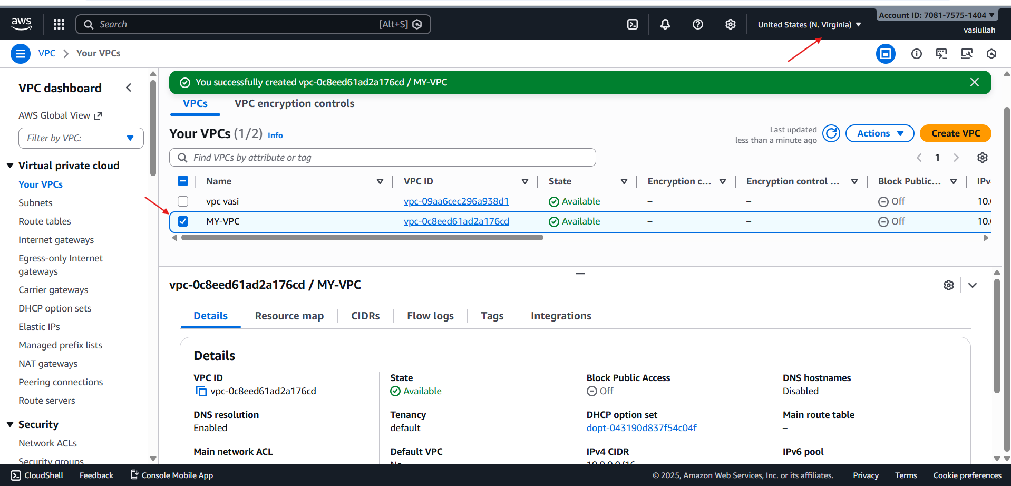

1. Create two subnets: one public subnet and one private subnet.

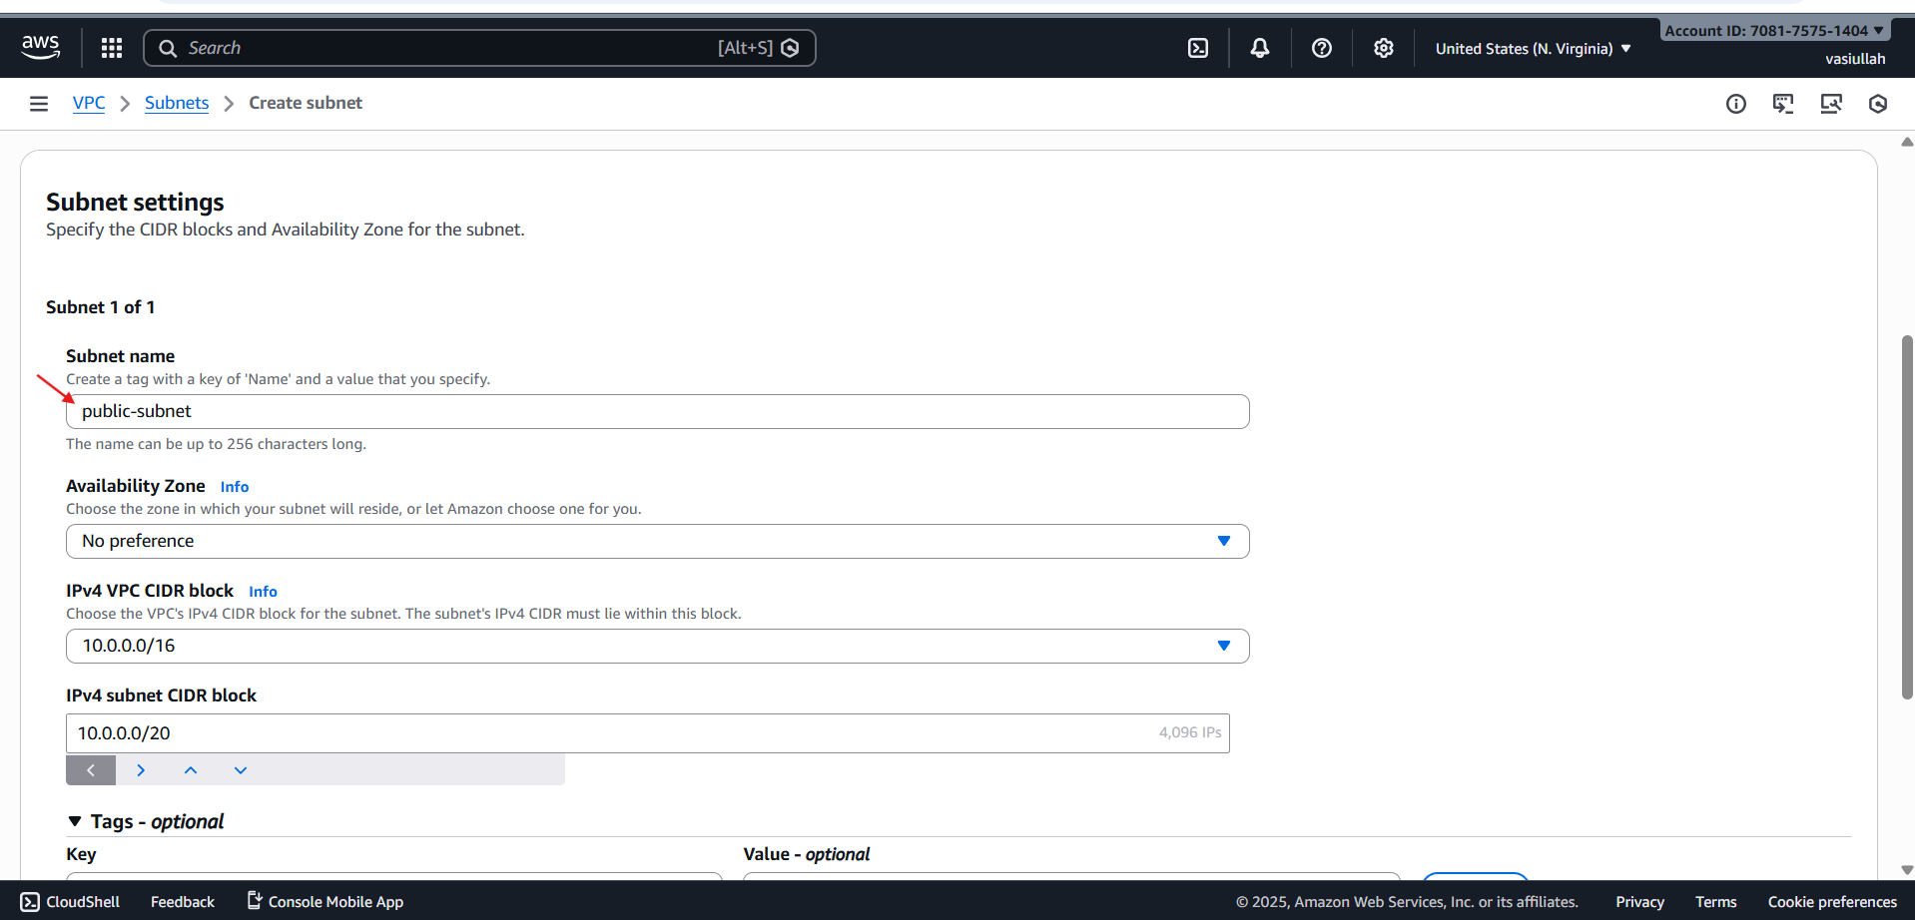

**Go to VPC → Subnets → Create subnet Public subnet**

**• VPC: my-vpc**

* **Name: public-subvpc1**

**• AZ: for example us-east-1a**

**• CIDR: 10.0.1.0/24**

* **Create Private subnet**

**• VPC: my-vpc1**

**• Name: private-subvpc1**

**• AZ: us-east-1a (same AZ as NAT for lab simplicity)**

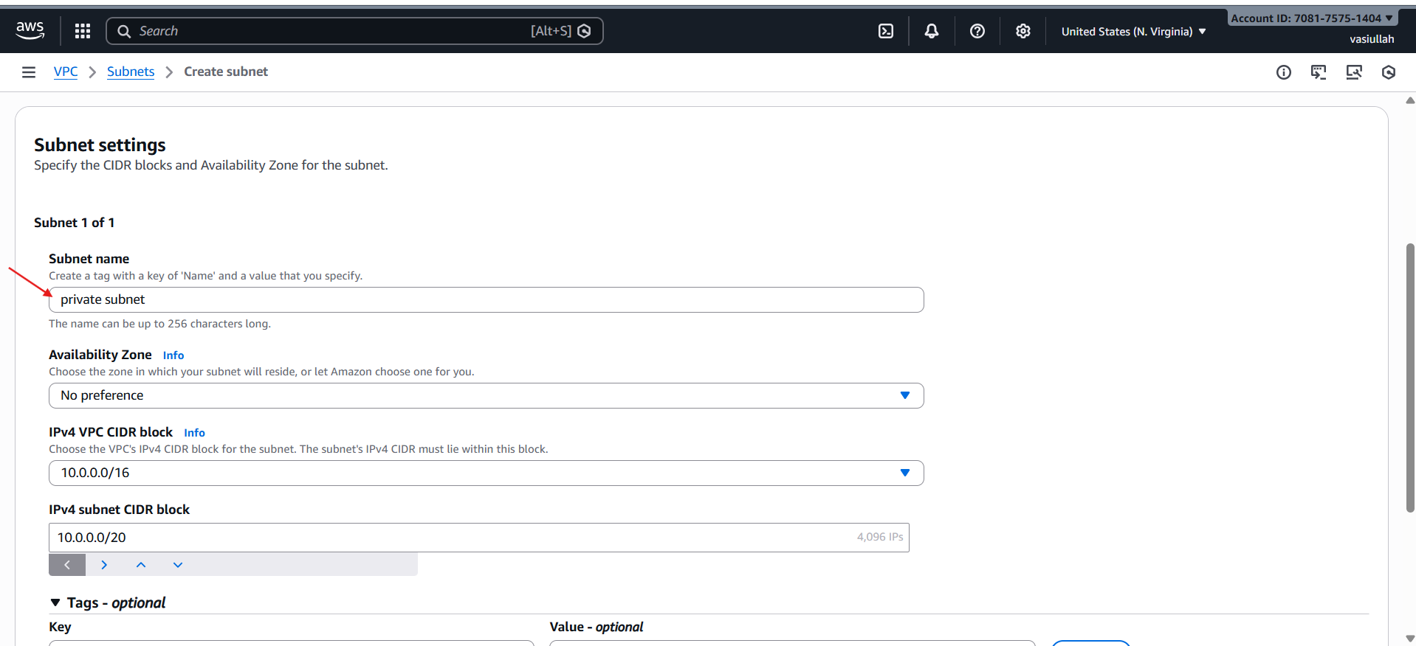

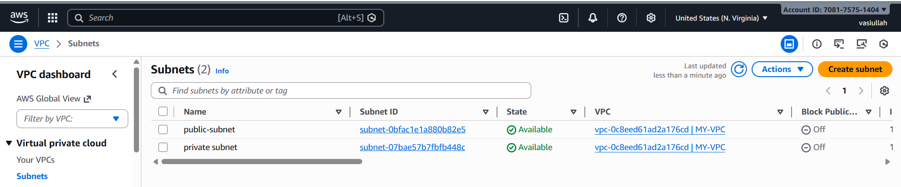

1. Attach an IGW to the VPC.

* **VPC → Internet gateways → Create internet gateway**

**◦ Name: myvpc1-igw→ Create 2.**

* **Select project-igw → Actions → Attach to VPC → choose project-vpc → Attach.**

**This IGW gives internet to resources in public subnet (through route table).**

* **attached the igw to the vpc**

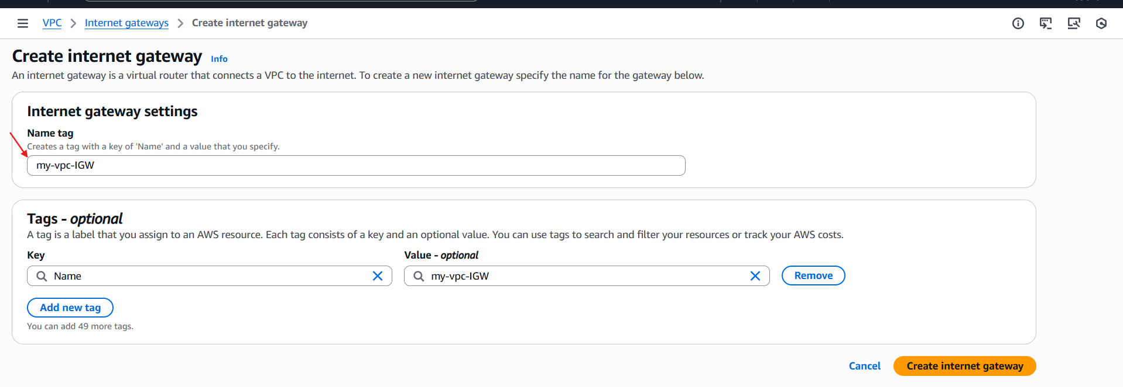

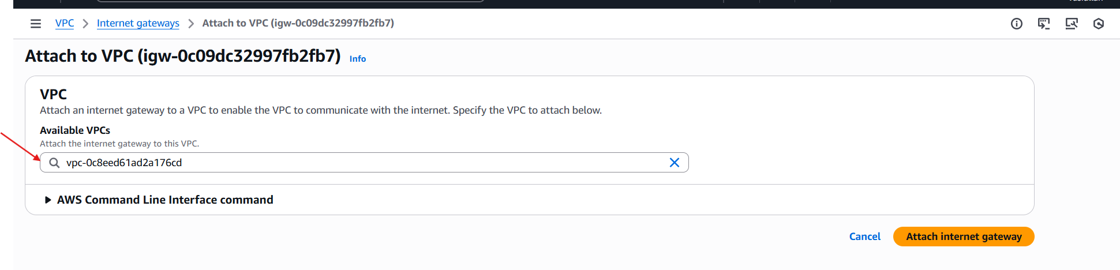

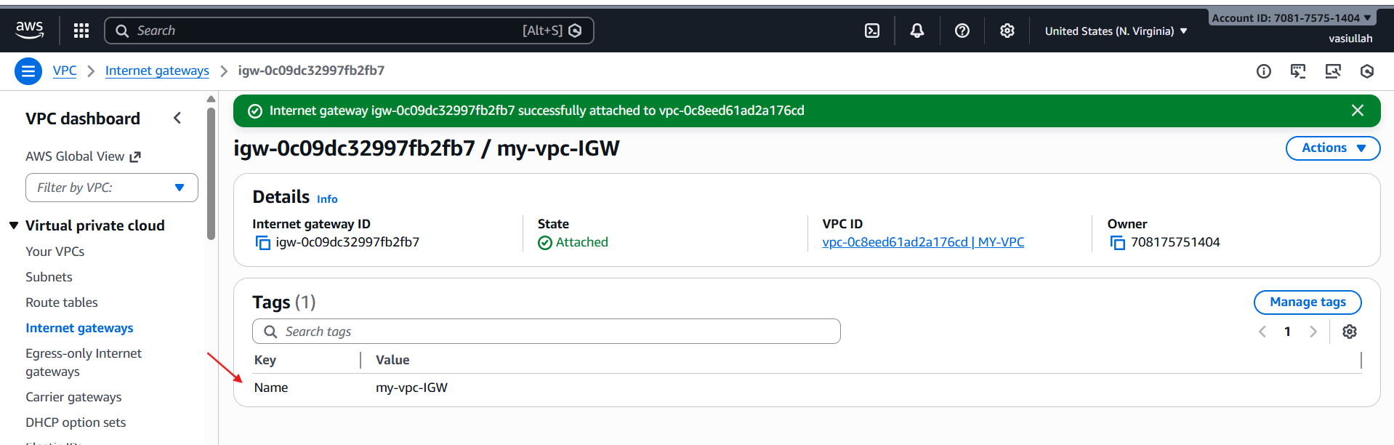

1. Create one public route table (RT) and one private route table.

* **VPC → Route tables → Create route table**

**• Name: public-route**

**• VPC: my-vpc**

* **Select public-rt → Routes tab → Edit routes:**

**• Add route:**

**◦ Destination: 0.0.0.0/0**

**◦ Target: Internet Gateway (project-igw)**

**• Save**

* **Subnet associations tab → Edit:**

**• Select public-route**

**• Save**

* **Private Route Table 1.**

**Create route table again:**

**◦ Name: myprivate-route**

**◦ VPC: my-vpc1 → Create 2.**

* **(Routing to NAT we’ll do after creating NAT)**
* **Subnet associations:**

**◦ Associate private-subnet-1 to private-rt**

* **private route table is created**

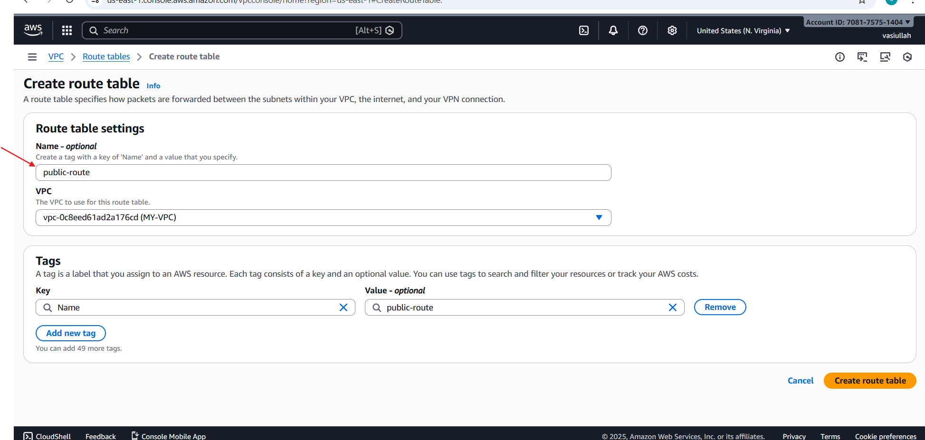

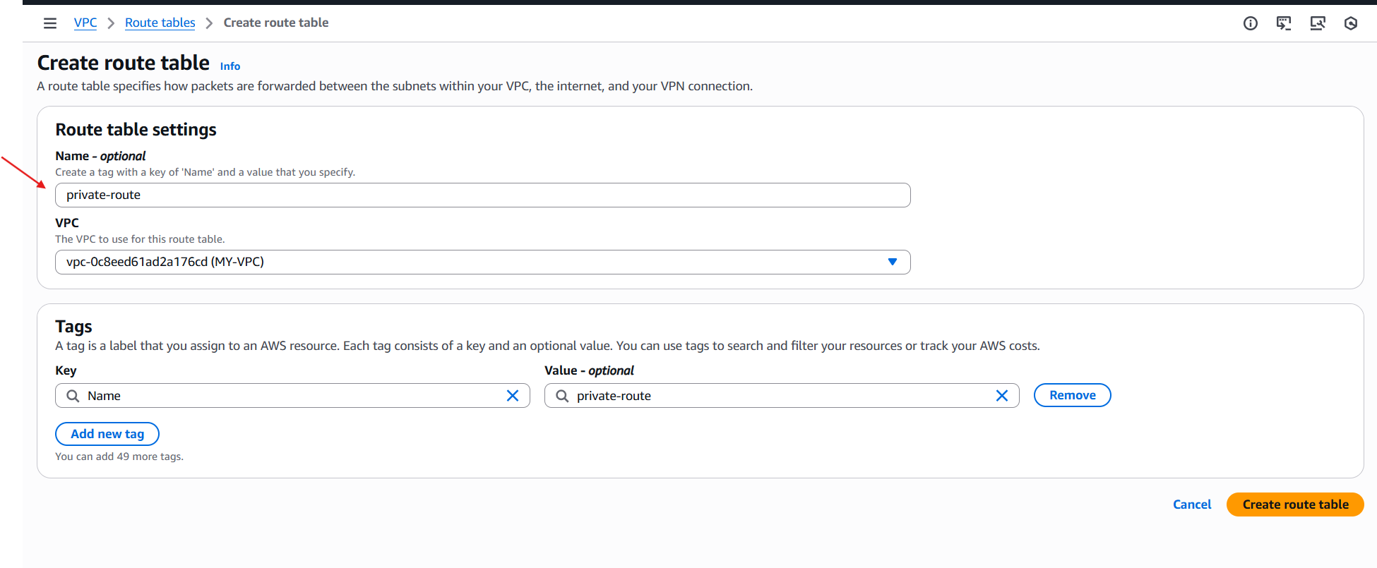

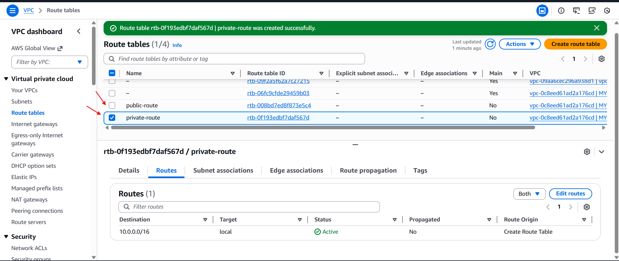

1. Deploy a NAT gateway in the public subnet and attach the NAT gateway to the private subnet.

* **Go to VPC → NAT gateways → Create NAT gateway**

**◦ Name: my-nat-gateway**

**◦ Vpc**

**◦ Elastic IP: click Allocate Elastic IP and choose it**

**◦ Create**

* **After NAT is Available, edit private-rt routes:**

**◦ Select private-rt → Routes → Edit routes → Add route**

**▪ Destination: 0.0.0.0/0**

**▪ Target: NAT Gateway (project-nat)**

**◦ Save Now private subnet can go out to internet (yum/apt updates) but internet cannot directly reach it.**

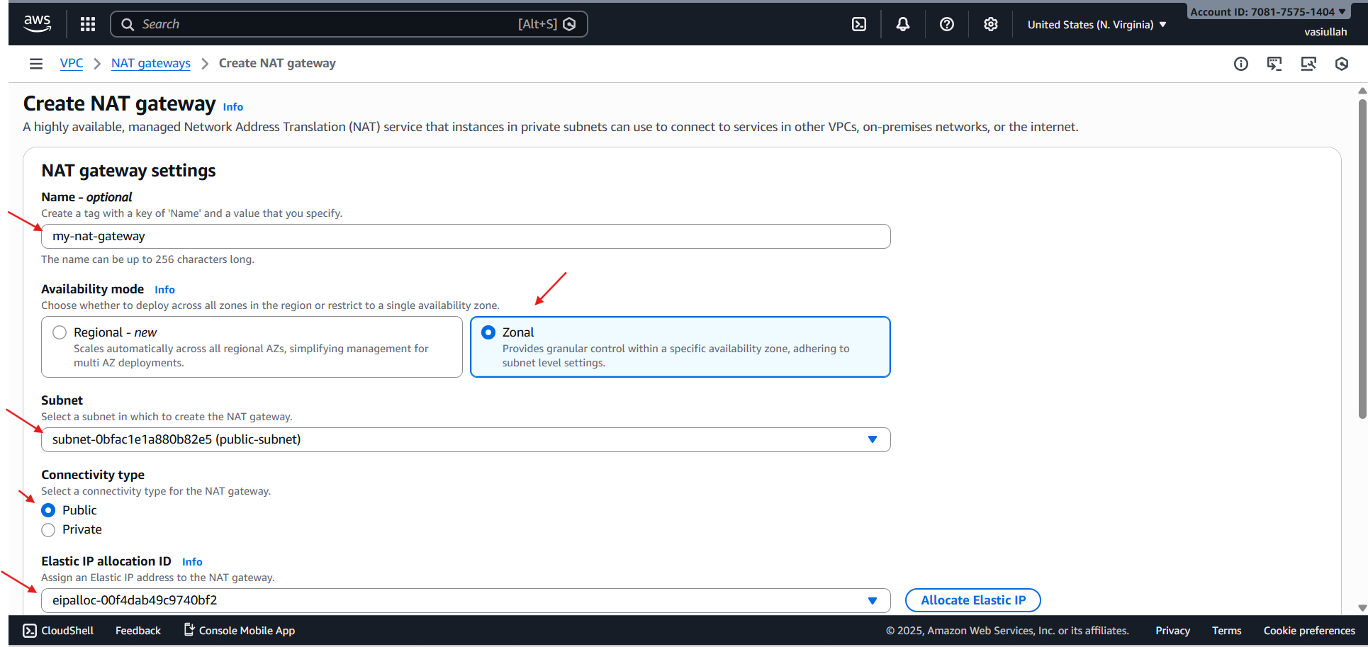

* **Go to private route and attach the nat gateway**

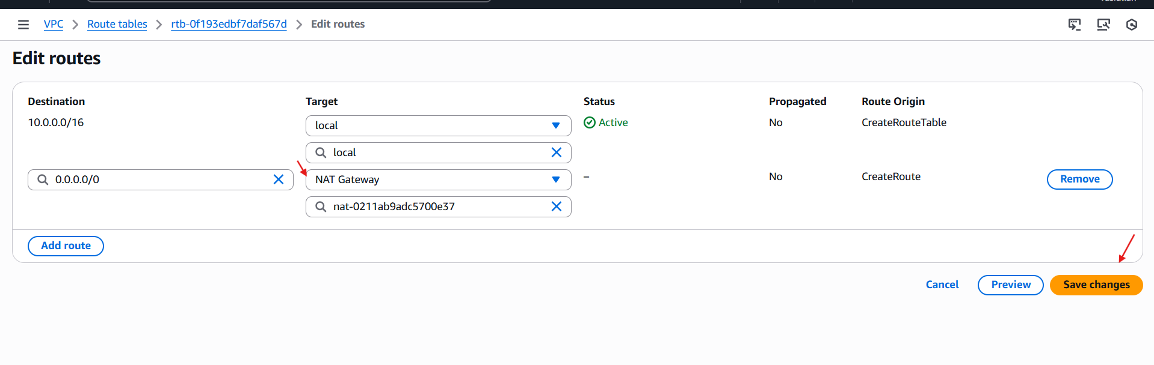

* **Nat gate way is attached to the private route table**

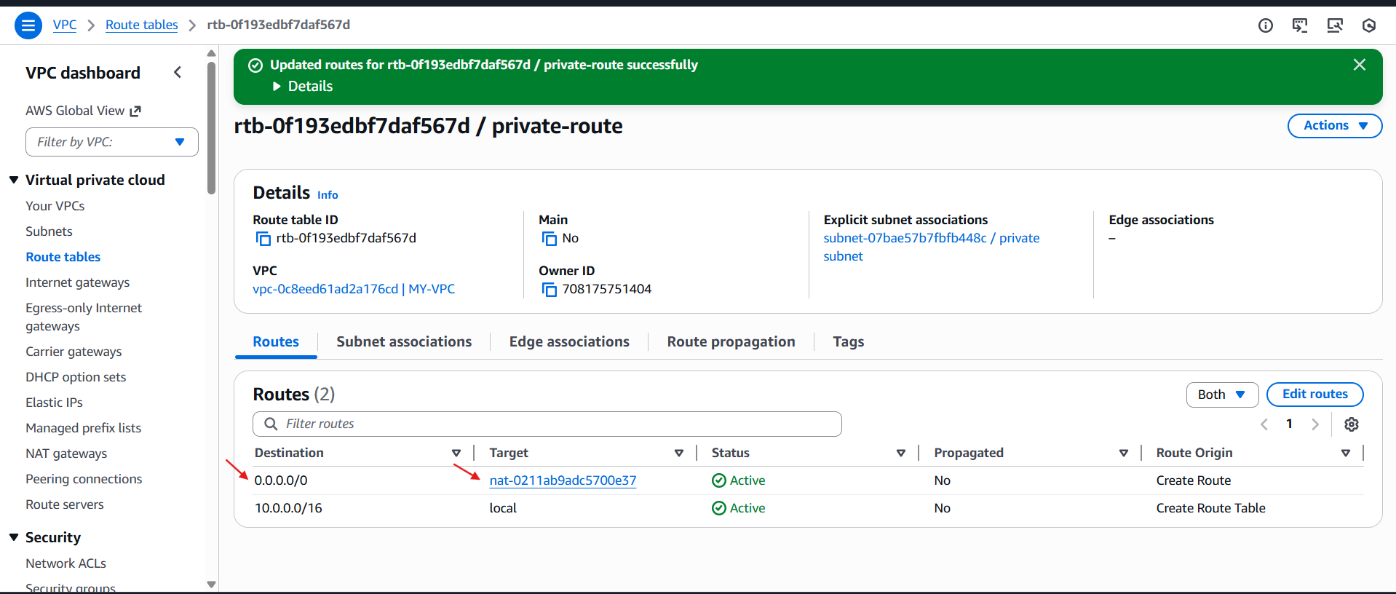

1. Create two instances, one in the public subnet and one in the private subnet.

* **Steps:**
* **Create EC2 instances (1 public, 1 private)**
* **select the vpc which we created and for public ec2 select public subnet**
* **And for same in private instance choose created vpc and select the private subnet of the vpc**
* **And launch the instance**
* **before launching I have added the script for installing httpd apache in data centre from task 7**

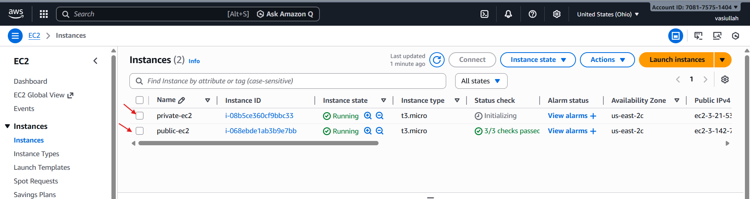

1. Deploy Apache server on both EC2 instances with a sample index.html file.

* **For public ec2 added the above script**

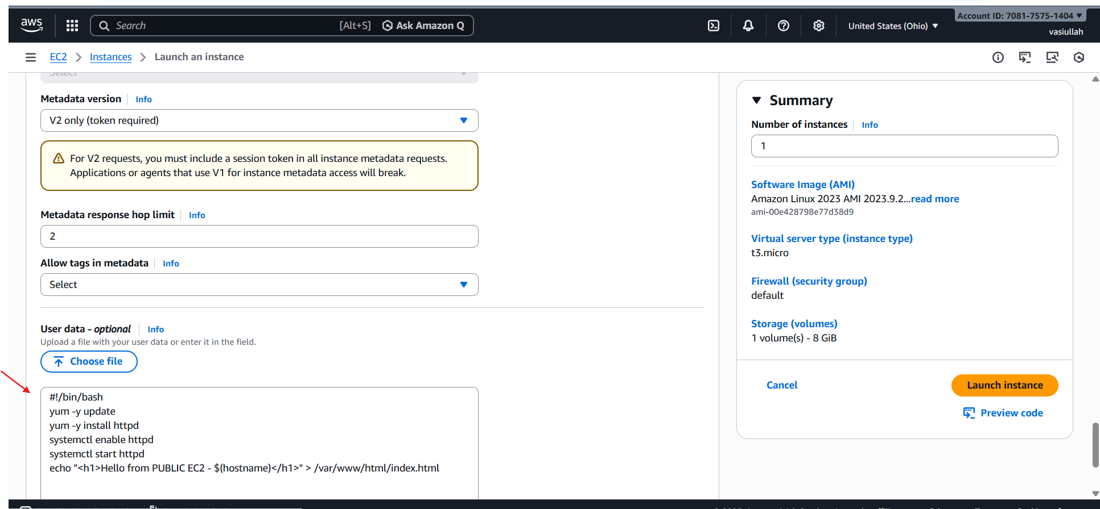

* **For private ec2 added the below data**

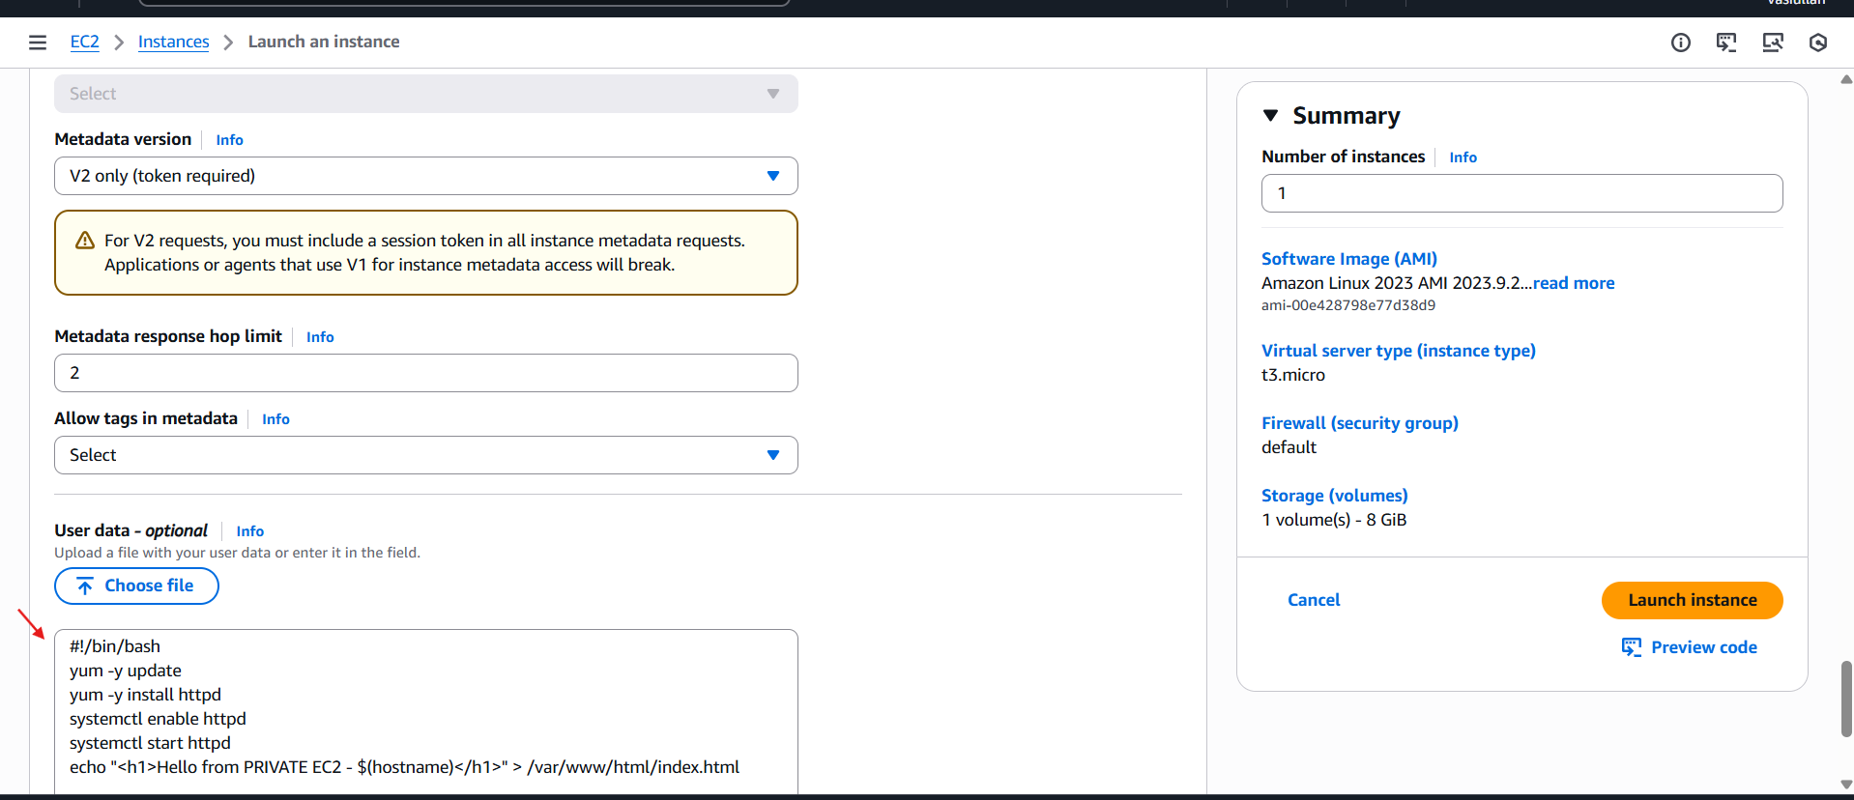

* **Now to check the httpd index.html page is running login to the public ec2**

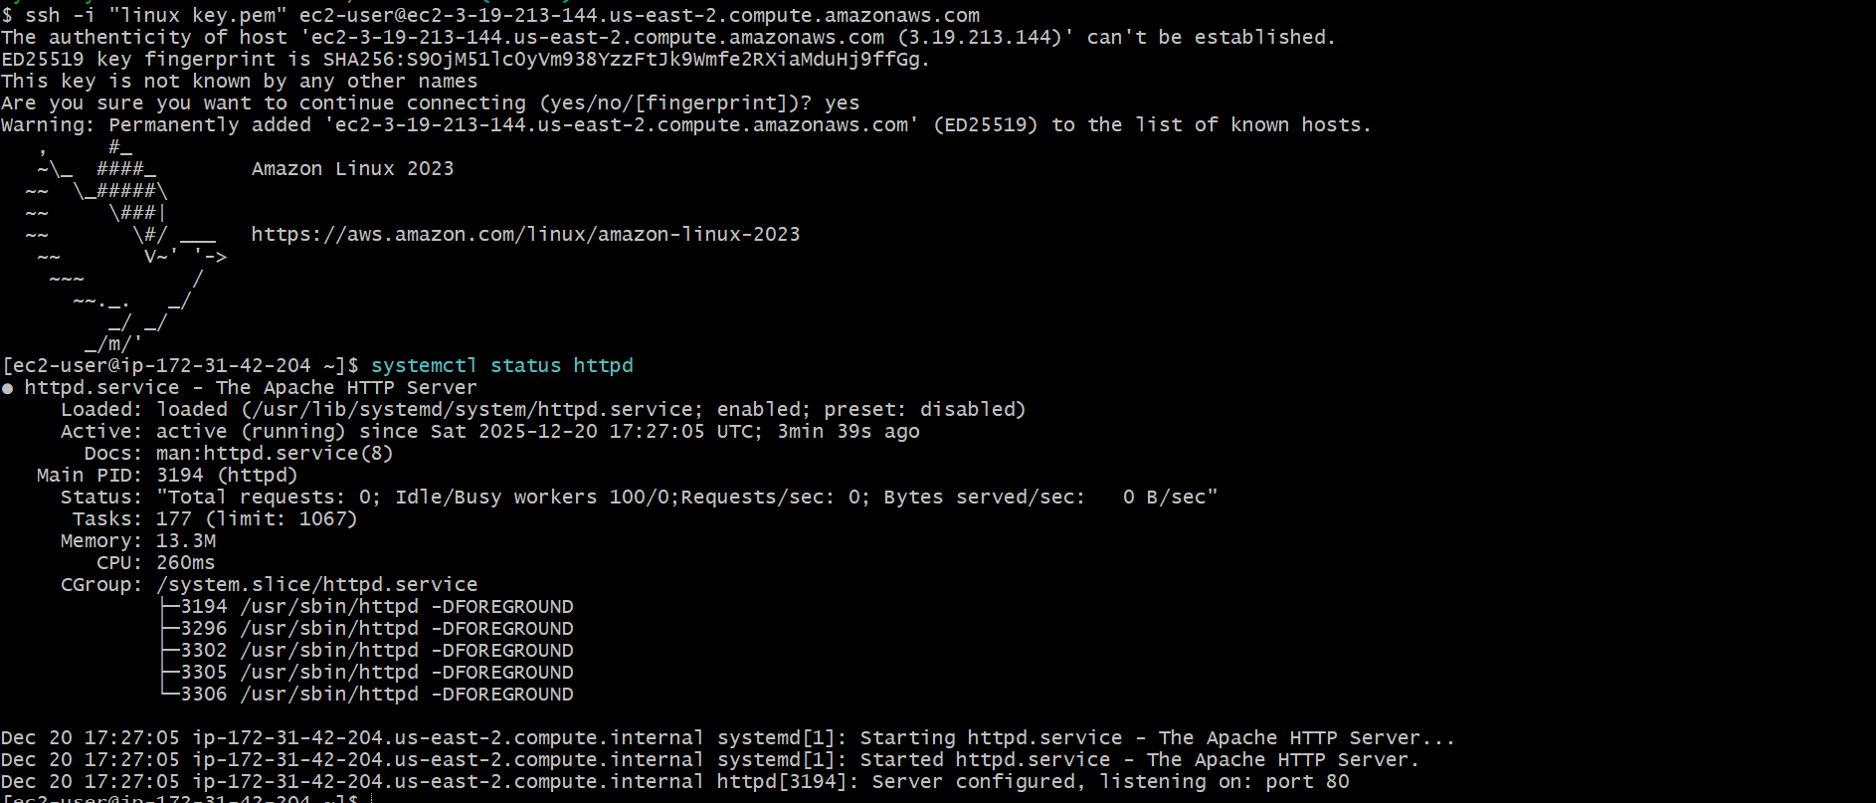

* **Now browse the public ip of the public ec2 to check index.html sample page**
* **we can see through image the apache is running**



* **Now lets login to our private ec2**
* **step to login in private ec2**
* **first we have to copy the pem key by cat and**
* **create a file name test.pem in public instance**
* **And add the pem key content inside the test.pem file**
* **give chmod 400 for permission**

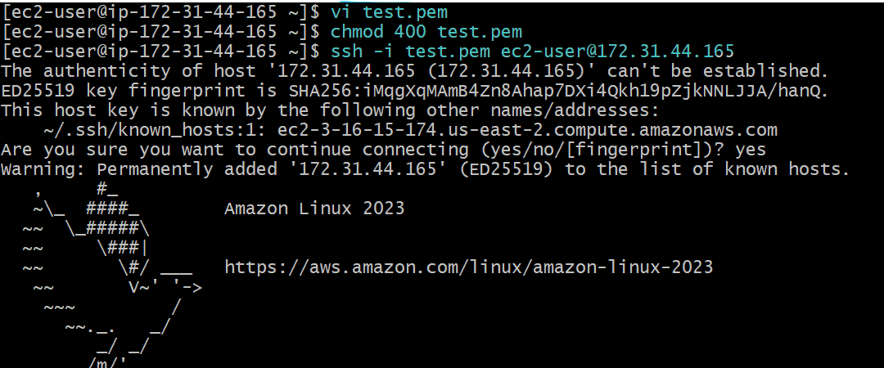

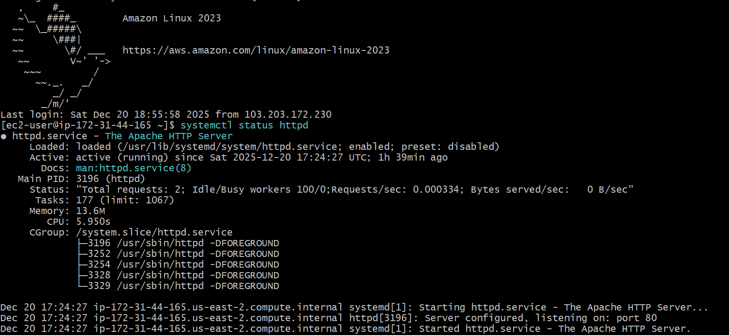

* **And ssh -I “test.pem” ec2-user@**
* **By this we can successfully login to aur private ec2**
* **Now to check if it has httpd as we have connected nat gate way I should have internet access**



1. Create one application load balancer and attach it to both EC2 instances.

* **first create a target group for the load balancer**

**Step 1: Create Target**

* **Go to EC2 → Load Balancing → Target Groups**
* **Click Create target group**
* **Choose Instances**
* **Target group name: my-target-group**
* **Protocol: HTTP**
* **Port: 80**
* **VPC: select your VP**

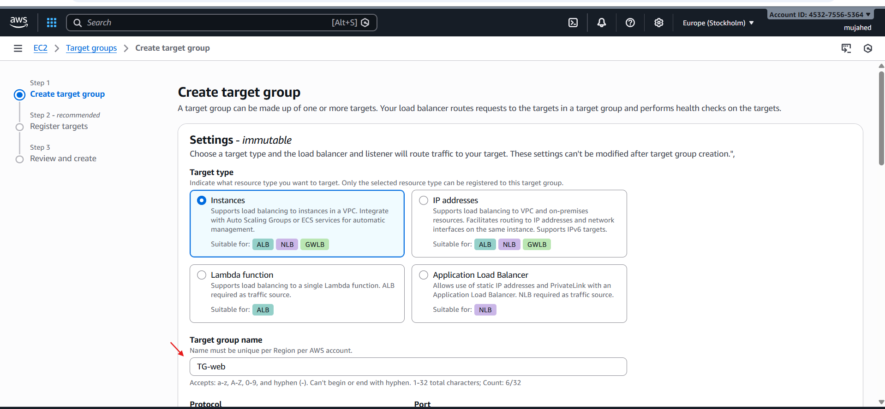

* **After that click next and you will be in register target step and we have to add the instances in register target**

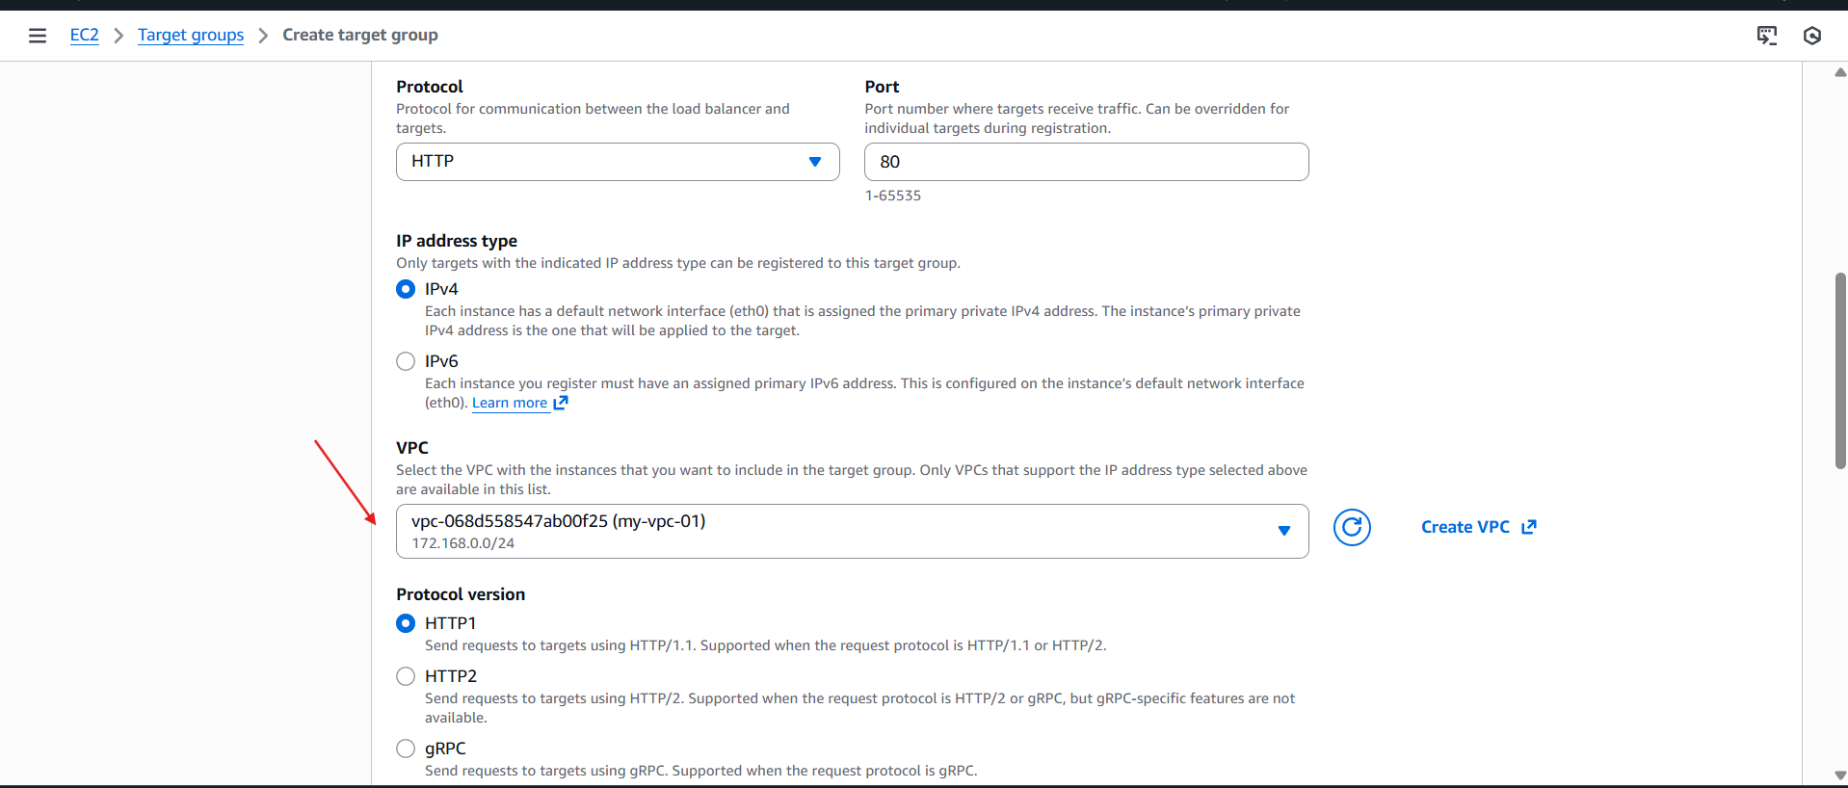

**Register both instances: • public-ec2 • private-ec2 Click Create target group**

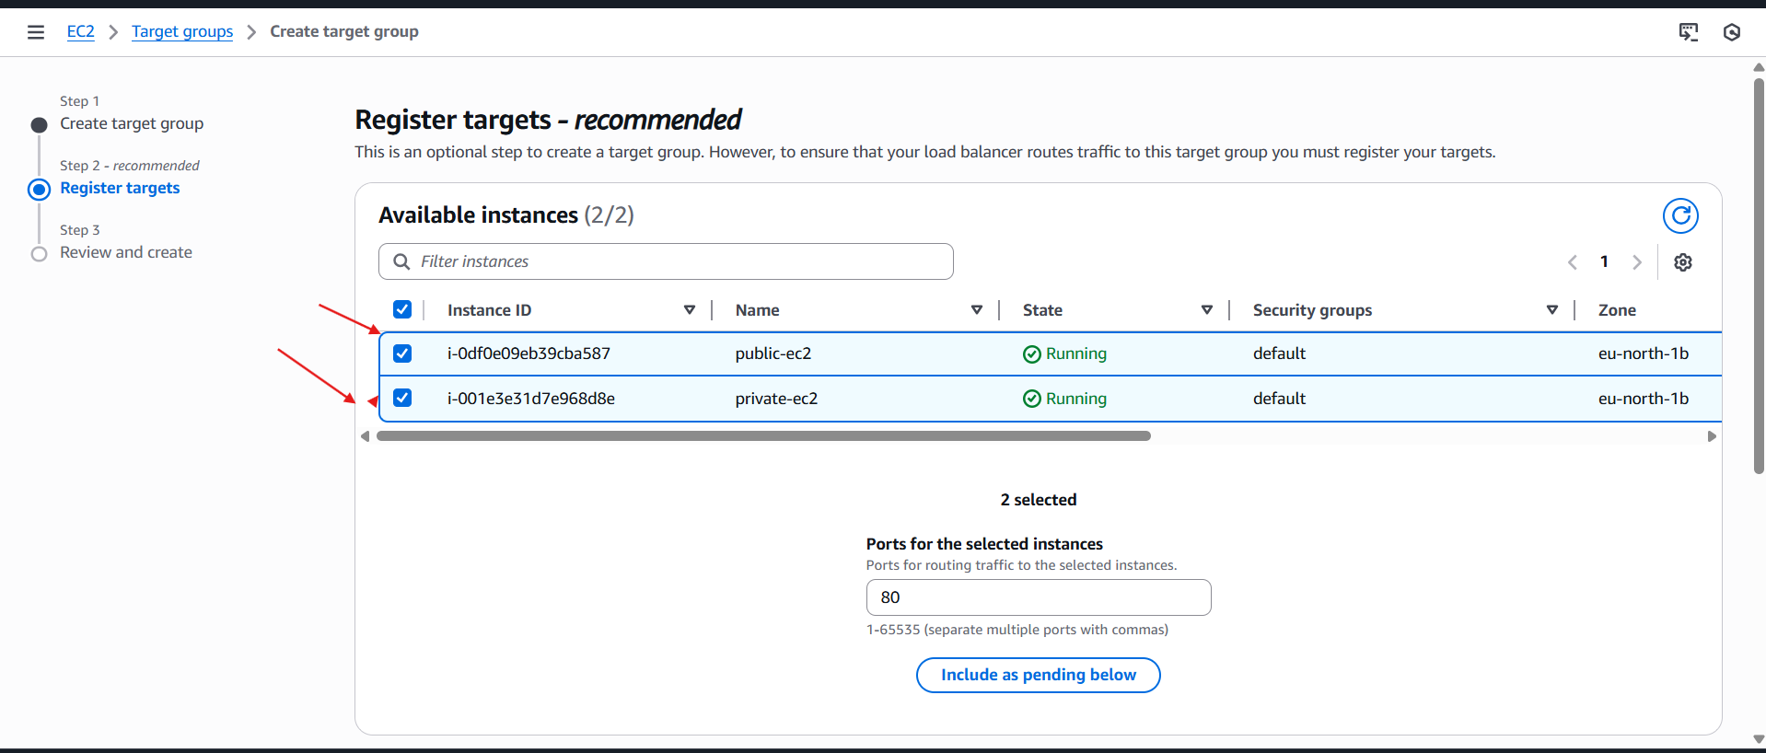

* **Register both instances:**

**• public-ec2**

**• private-ec2**

* **Click Create target group**

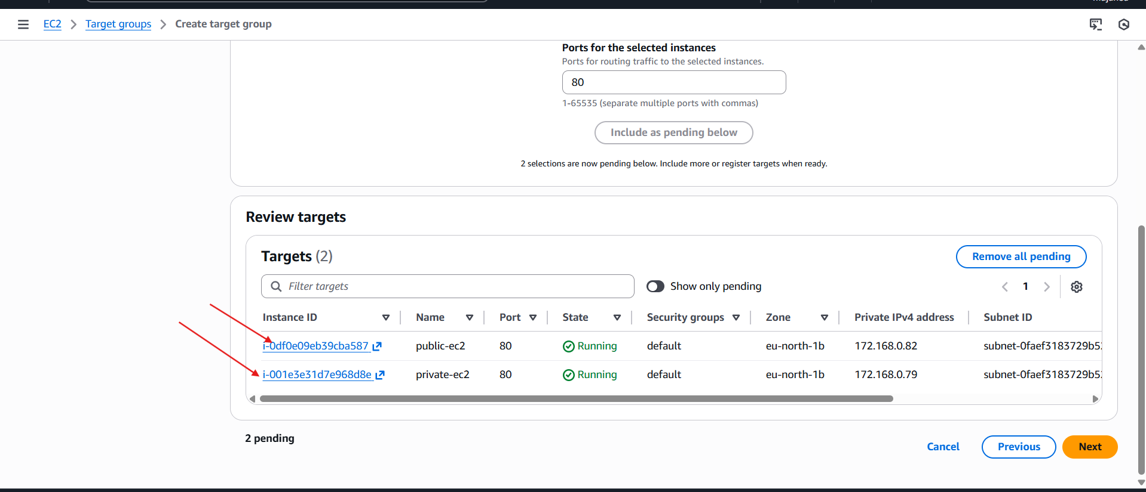

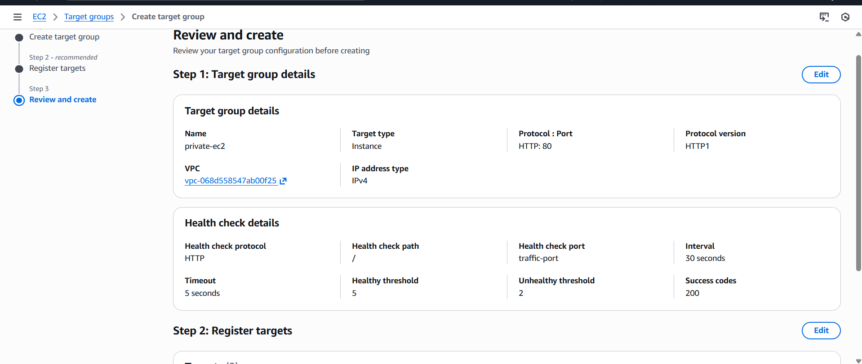

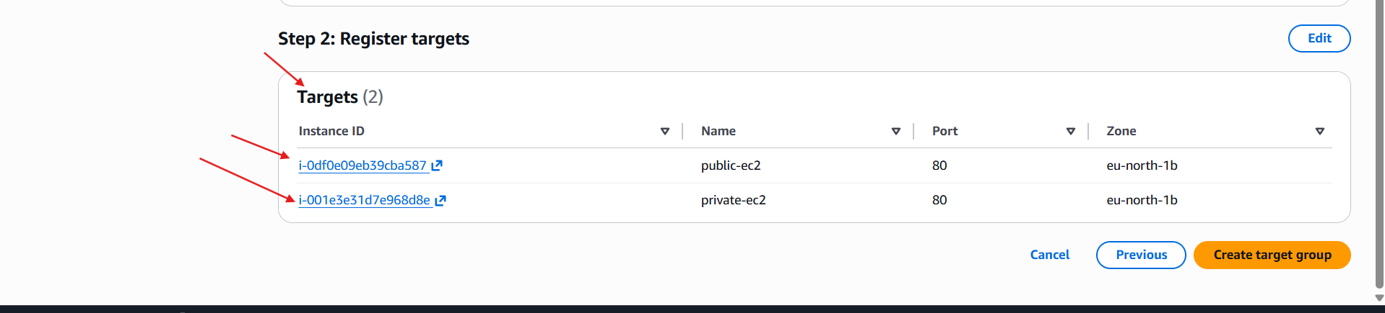

* **so currently we have created a “tg-web” named target groups**

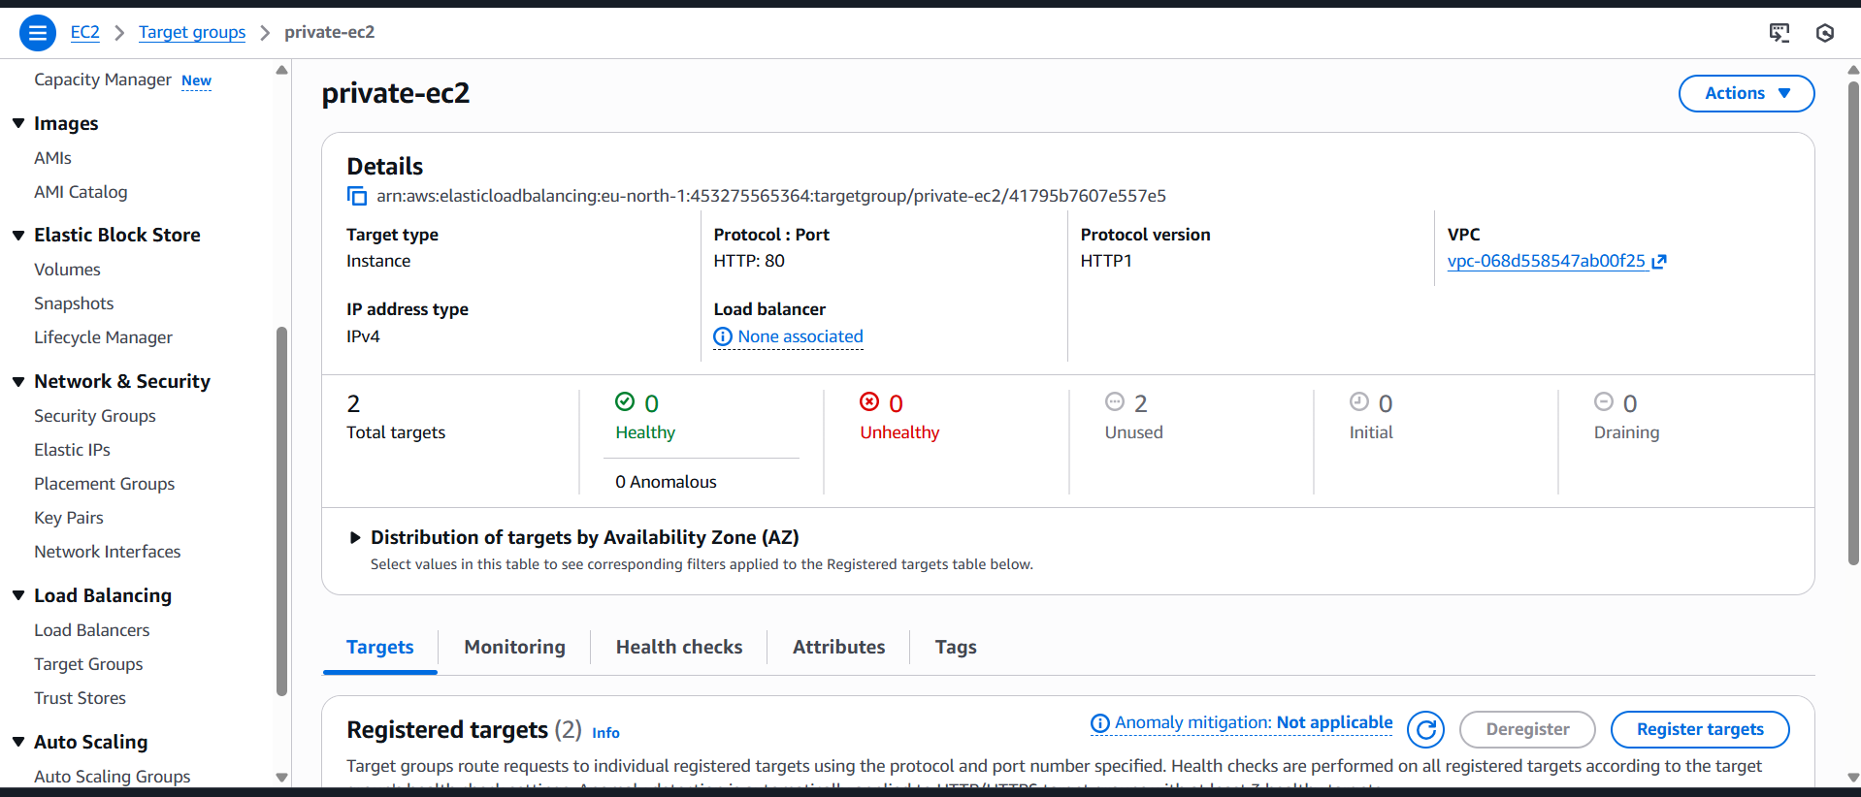

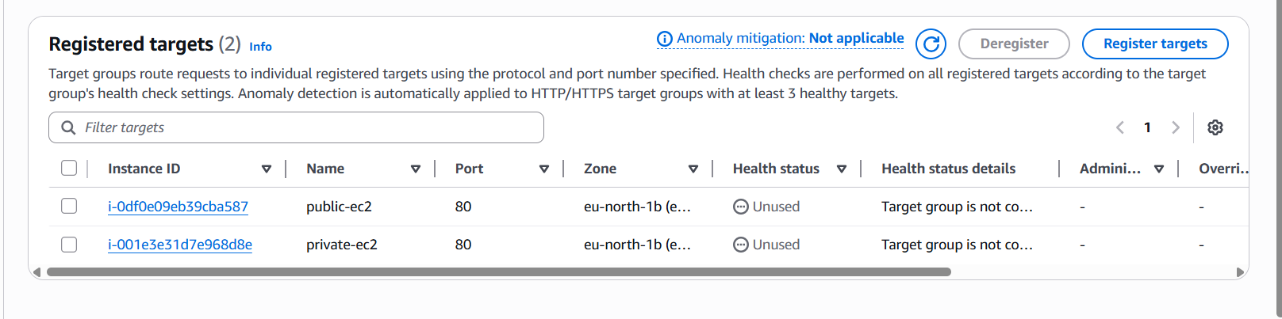

* **Now we have to create load balancer**

**Step 2: Create ALB**

* **Go to EC2 → Load Balancers**
* **Click Create Load Balancer → Application Load Balancer 3. Name:   my-alb**
* **Scheme: Internet-facing**
* **IP type: IPv4**
* **Select 2 public subnets (must have IGW route)**
* **Security group:**
* **Allow HTTP (80) from anywhere**
* **Listener: ◦ HTTP:80 → select my-target-group**
* **Click Create Load Balancer**

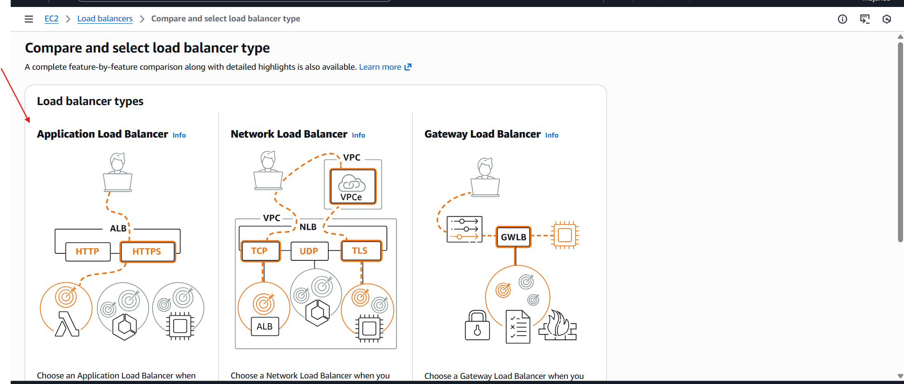

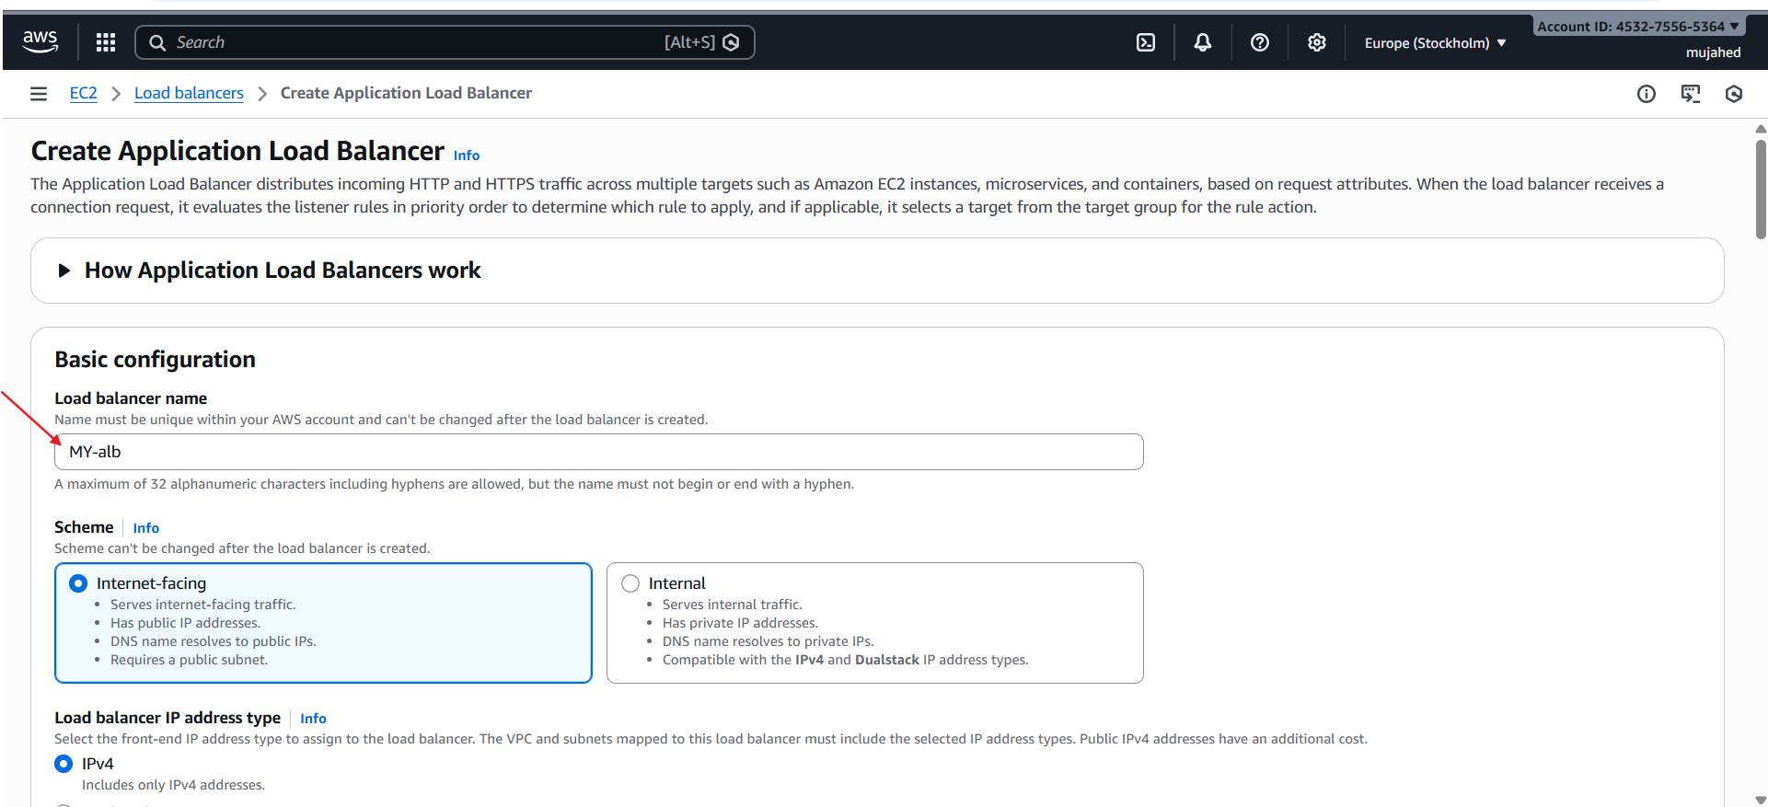

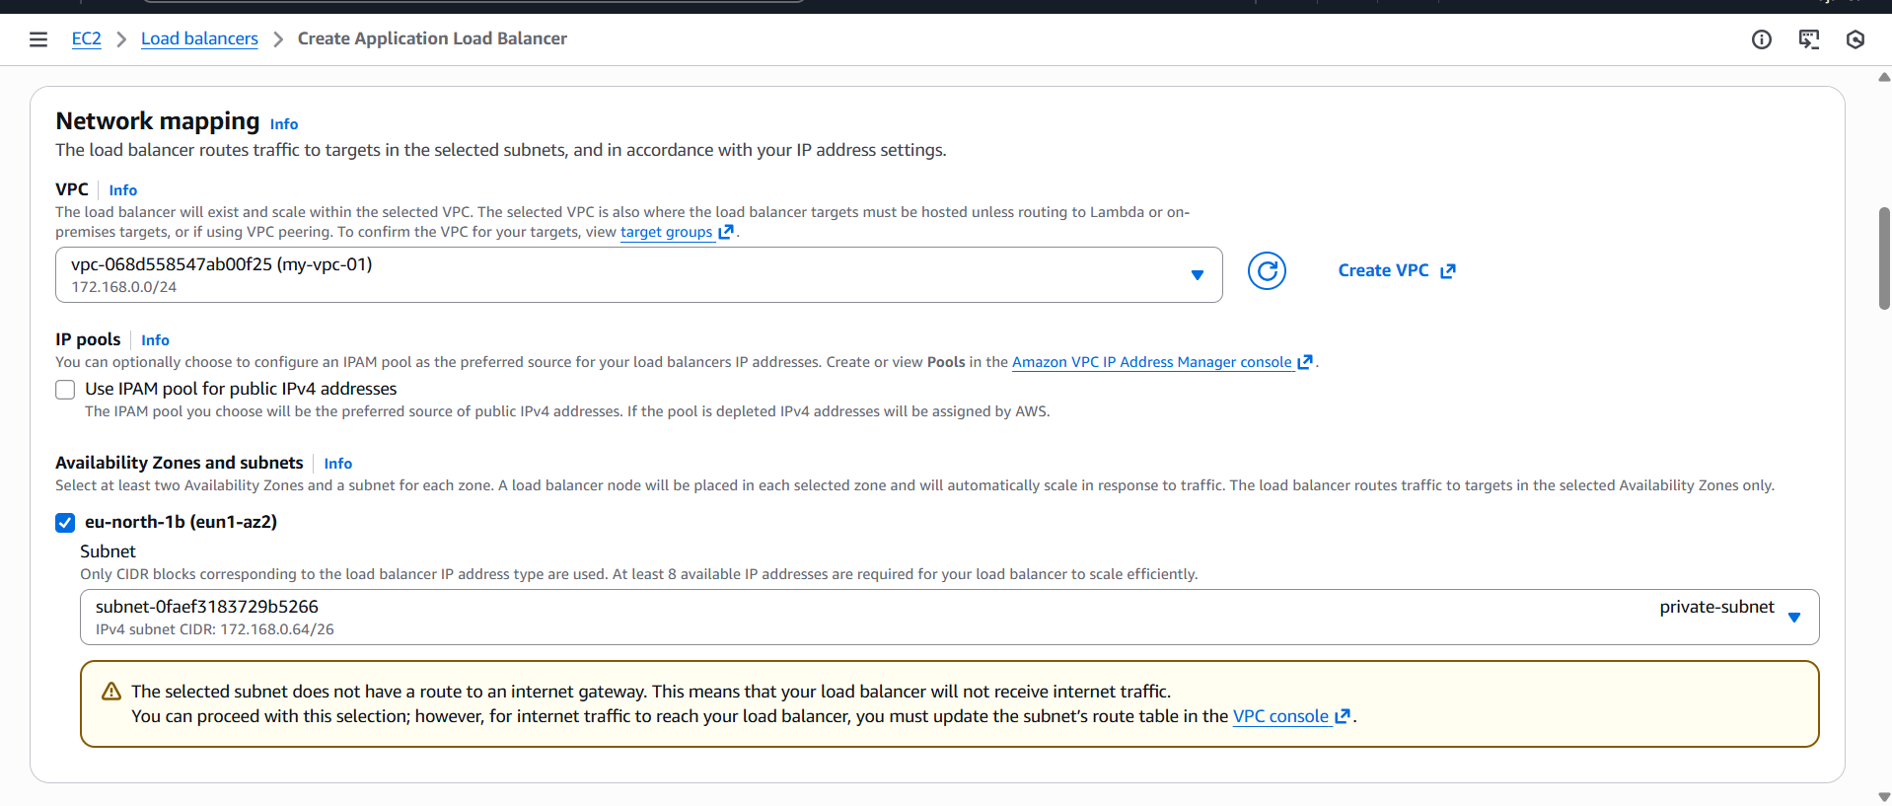

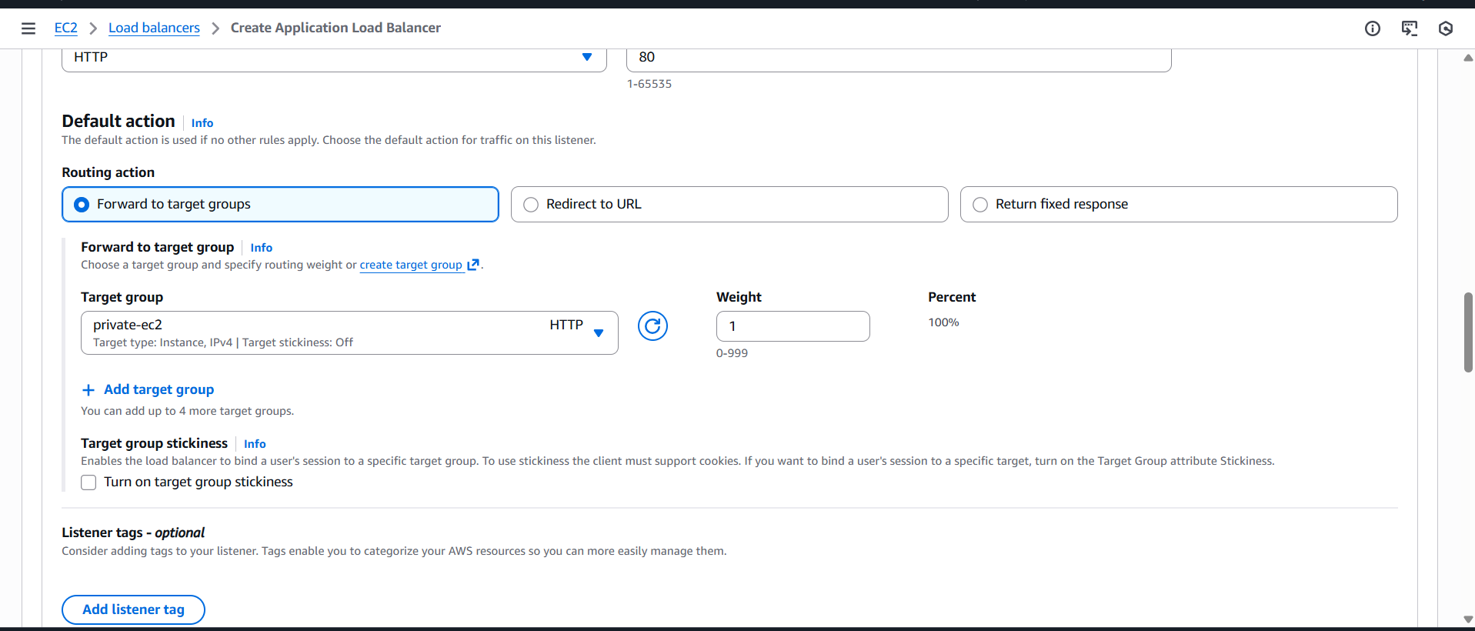

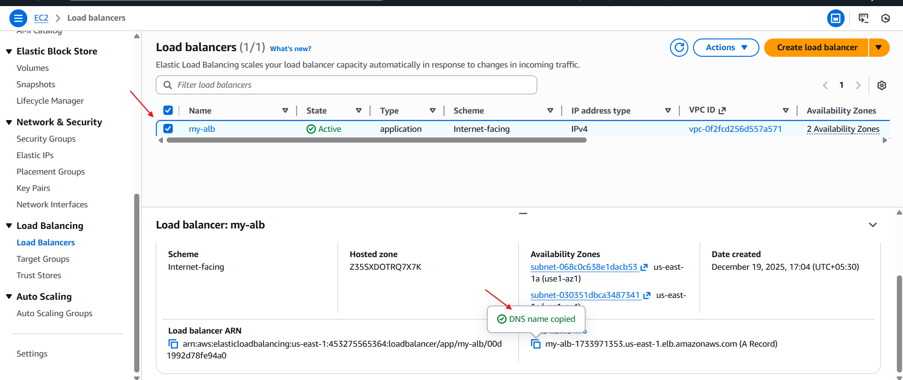



* **By this we have successfully created a application load balancer for and we have attached it with subnets (ec2)**

1. Store application load balancer logs in S3.

* **To store the logs of load balancer we have to create a s3 bucket Named with that load balancer**
* **I given the “my-alb-logs-vasi” as bucket name**
* **Block public access → Keep ON (default)**
* **Create bucket**

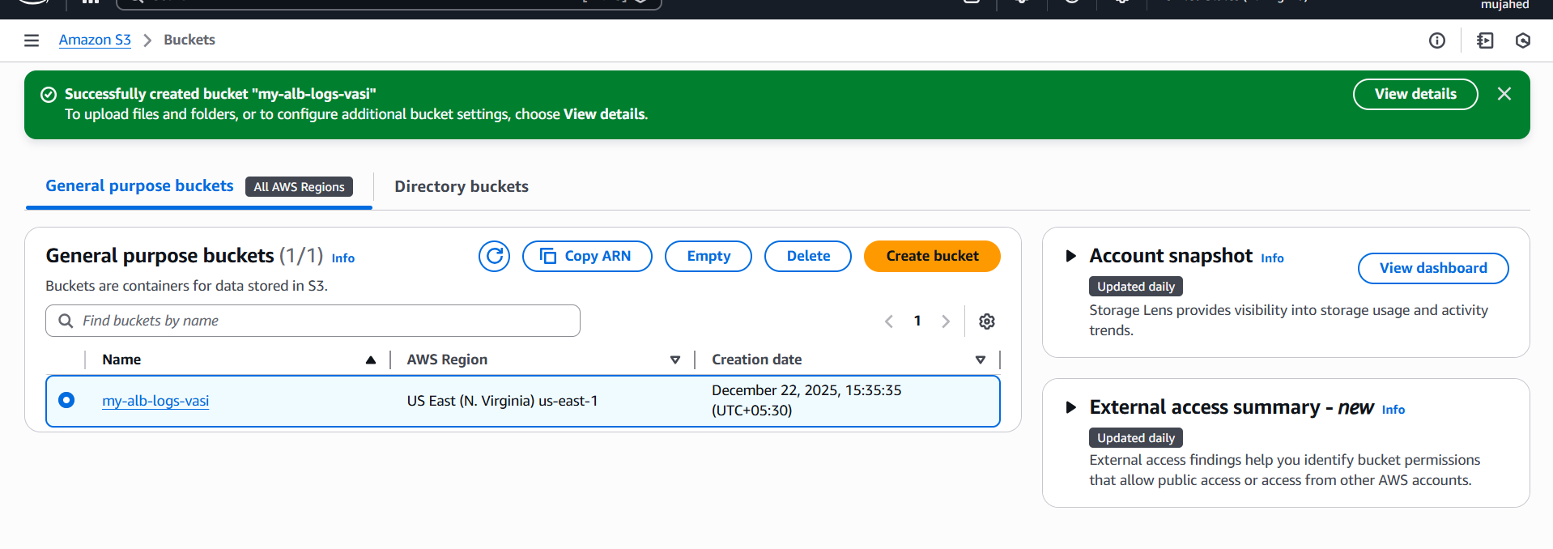

* **give the bucket policy for storing logs from load balancer**

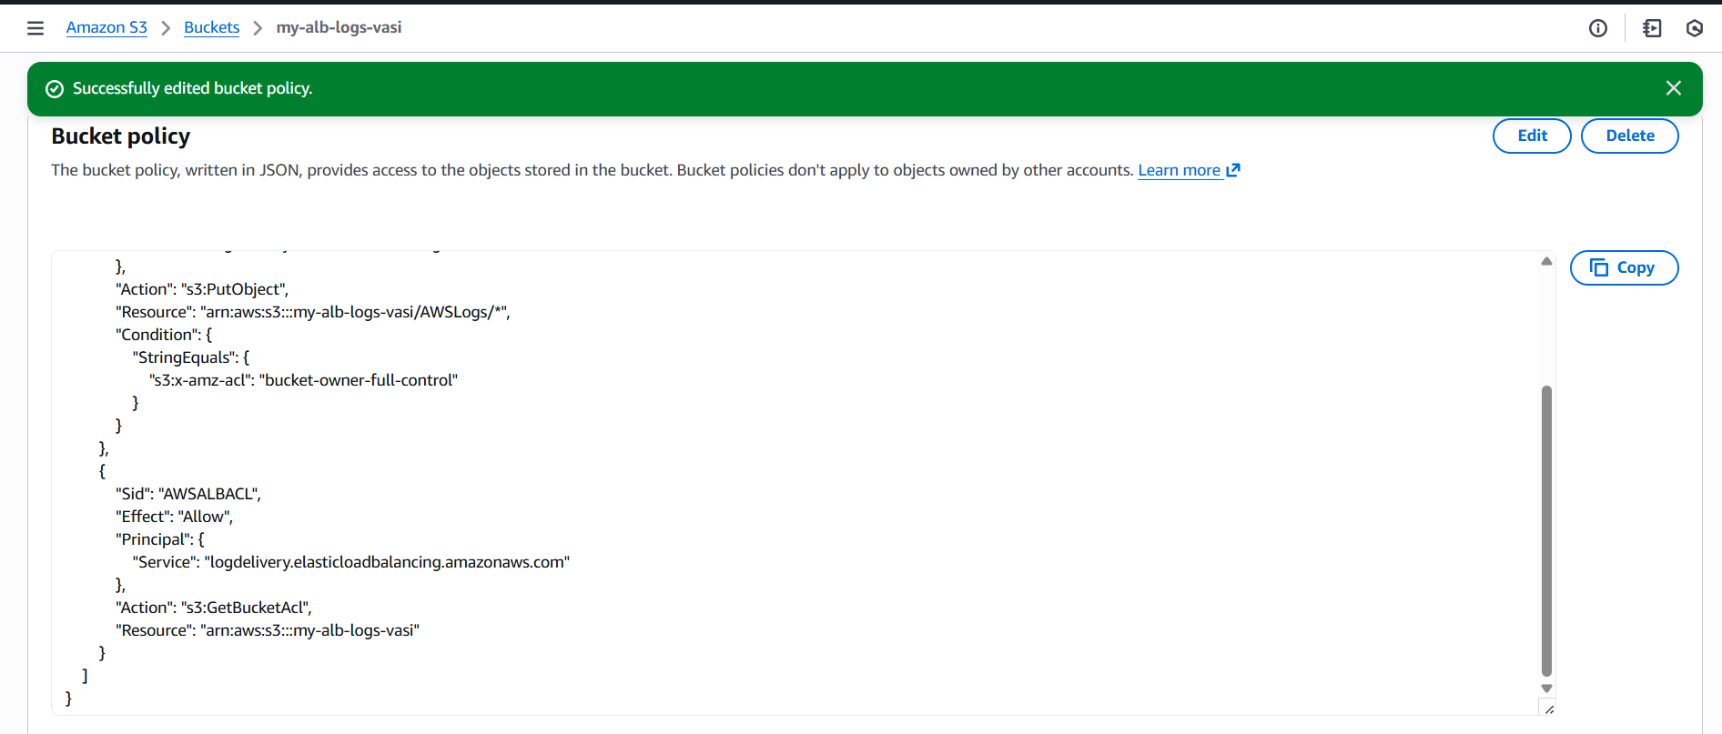

* **Now go to the load balancer —> my-alb—> and look for attributes**

**Enable ALB Logs**

* **Go to EC2 → Load balancers → my-alb**
* **Click Attributes**
* **Enable: Access Logs → ON**
* **Provide S3 bucket name: browse the name of the bucket which we created**

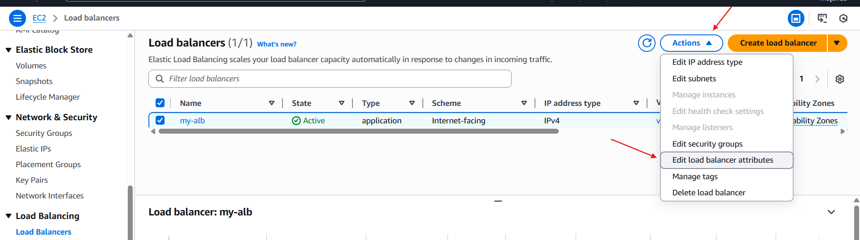

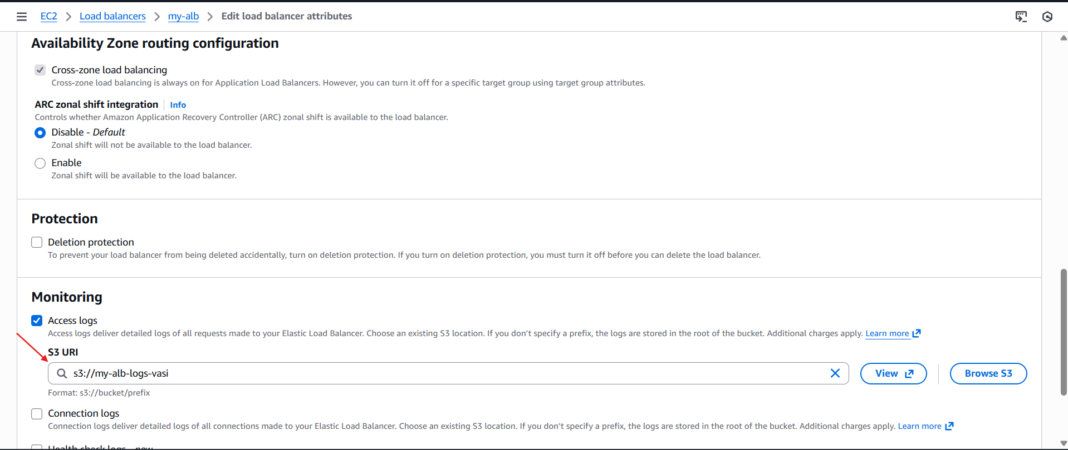

* **After this step click next**
* **After few minutes logs will appear inside S3.**

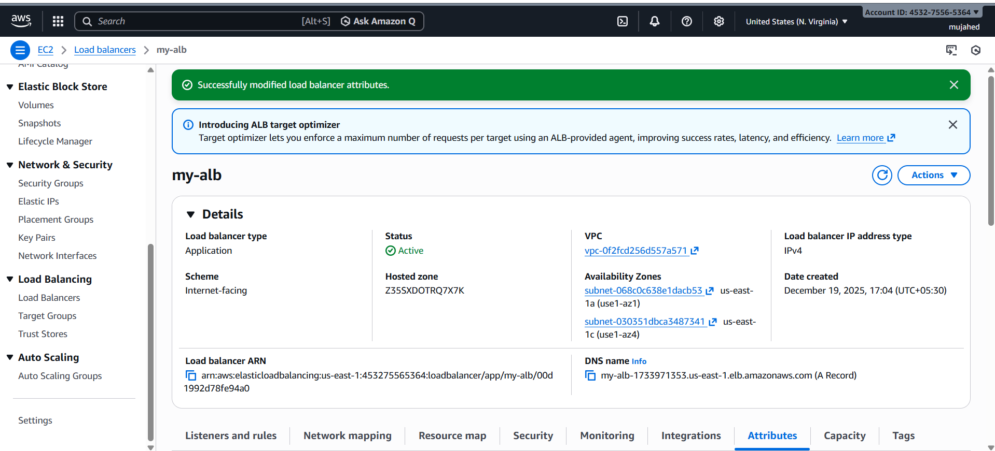

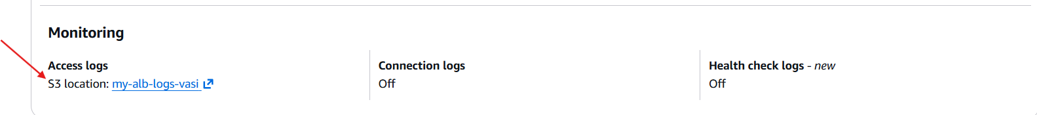

* **To view this logs go to the bucket and view object**

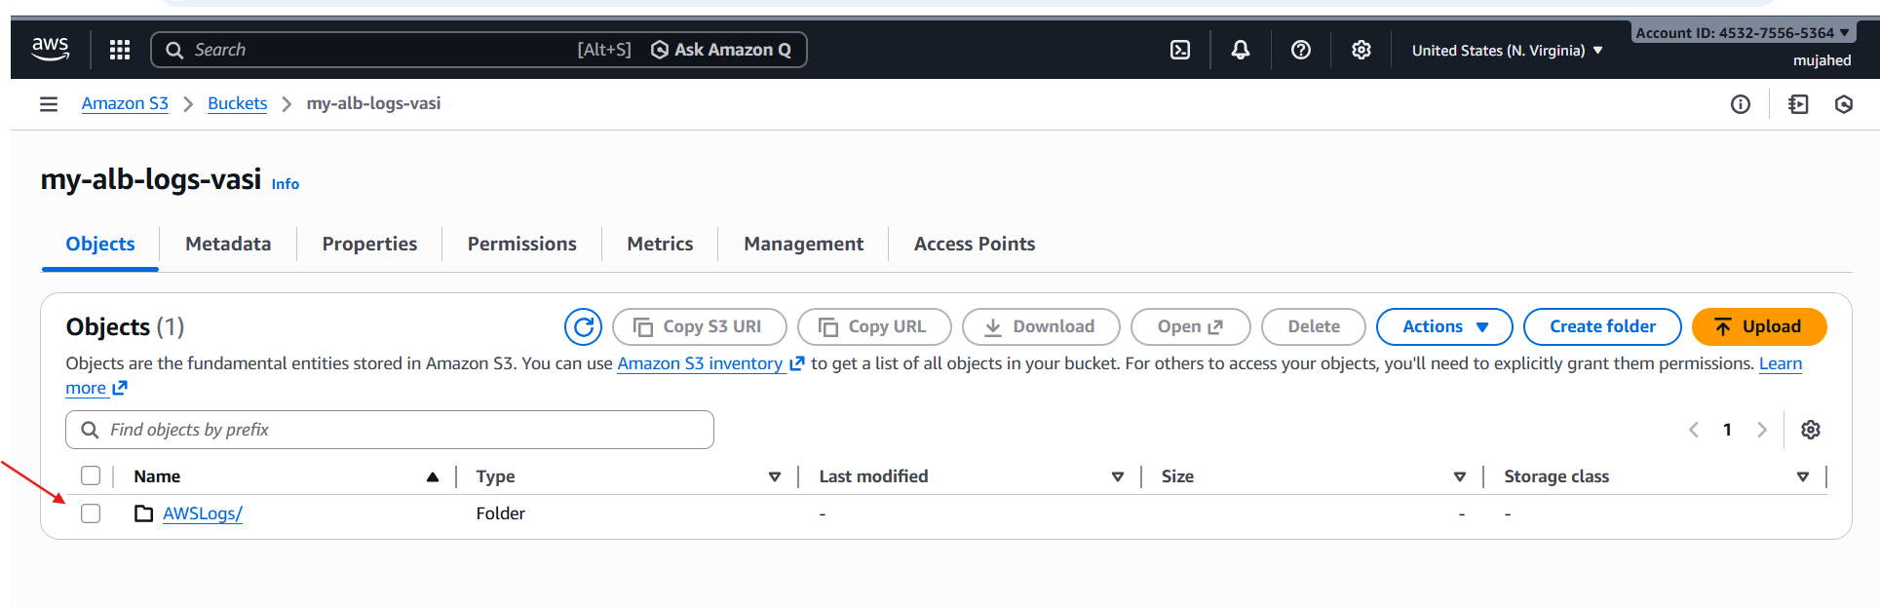

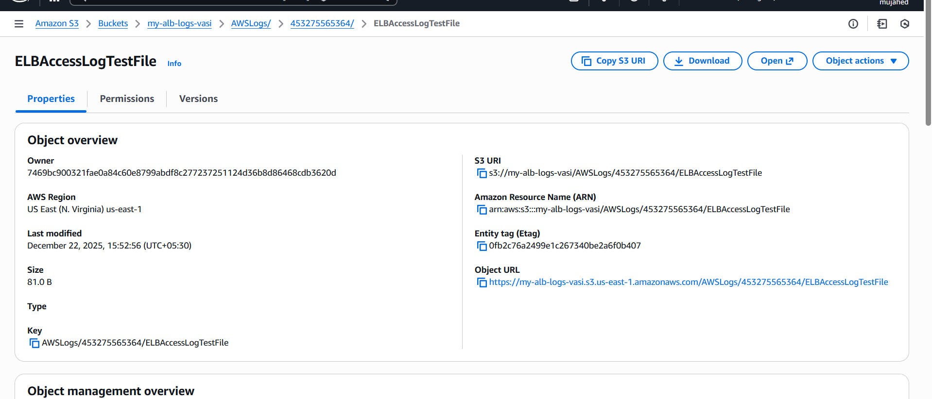

* **load balancer logs are being stored in our s3 bucket**

10.Store the VPC flow logs in a CloudWatch log group.

* **It will record all incoming + outgoing traffic inside your VPC (like who connected, from which IP, which port, etc.)**
* **steps:**
* **Create VPC Flow Logs**
* **Send flow logs into CloudWatch Log Group**
* **Not to S3 bucket**

**1: Open VPC Console**

* **Go to:**
* **AWS → VPC → Your VPCs Select your VPC**

**2: Create Flow Log**

* **After selecting your VPC:**
* **Left side → Flow logs → Click Create flow log**

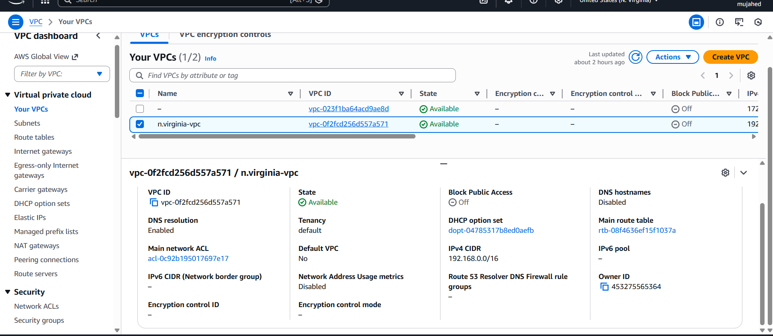

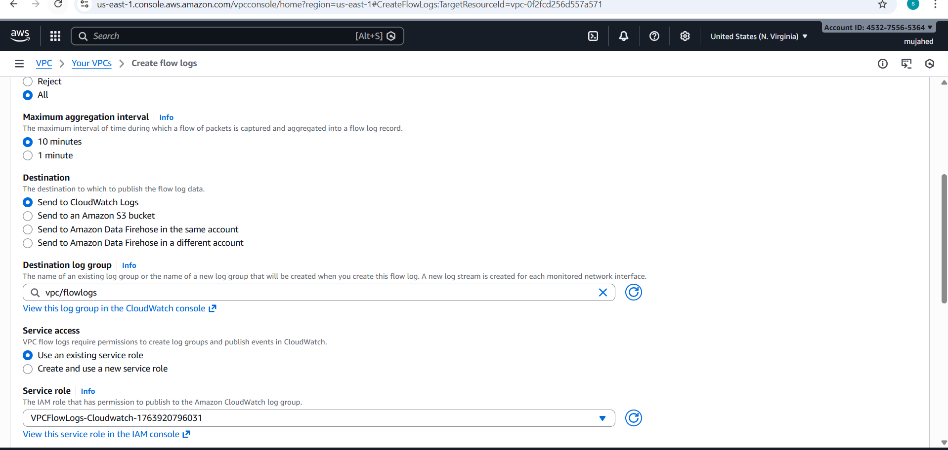

* **Correct Settings You Should Select**
* **Filter: All**
* **Max aggregation:1 minute**
* **Destination :Send to CloudWatch Logs**
* **Destination log group : vpc flowlogs ==> give a role name and keep other settings default**

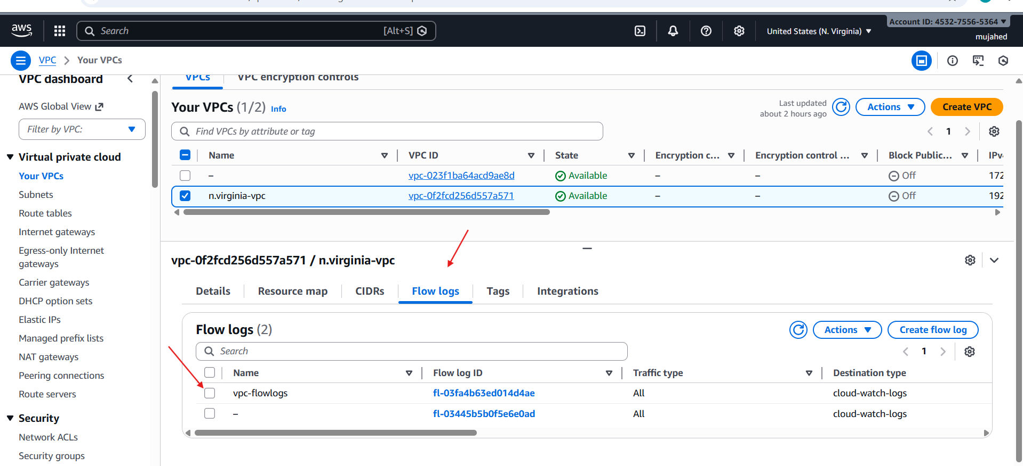

* **What You Should See Next**
* **Inside CloudWatch:**
* **Log Groups → /vpc/flowlogs**

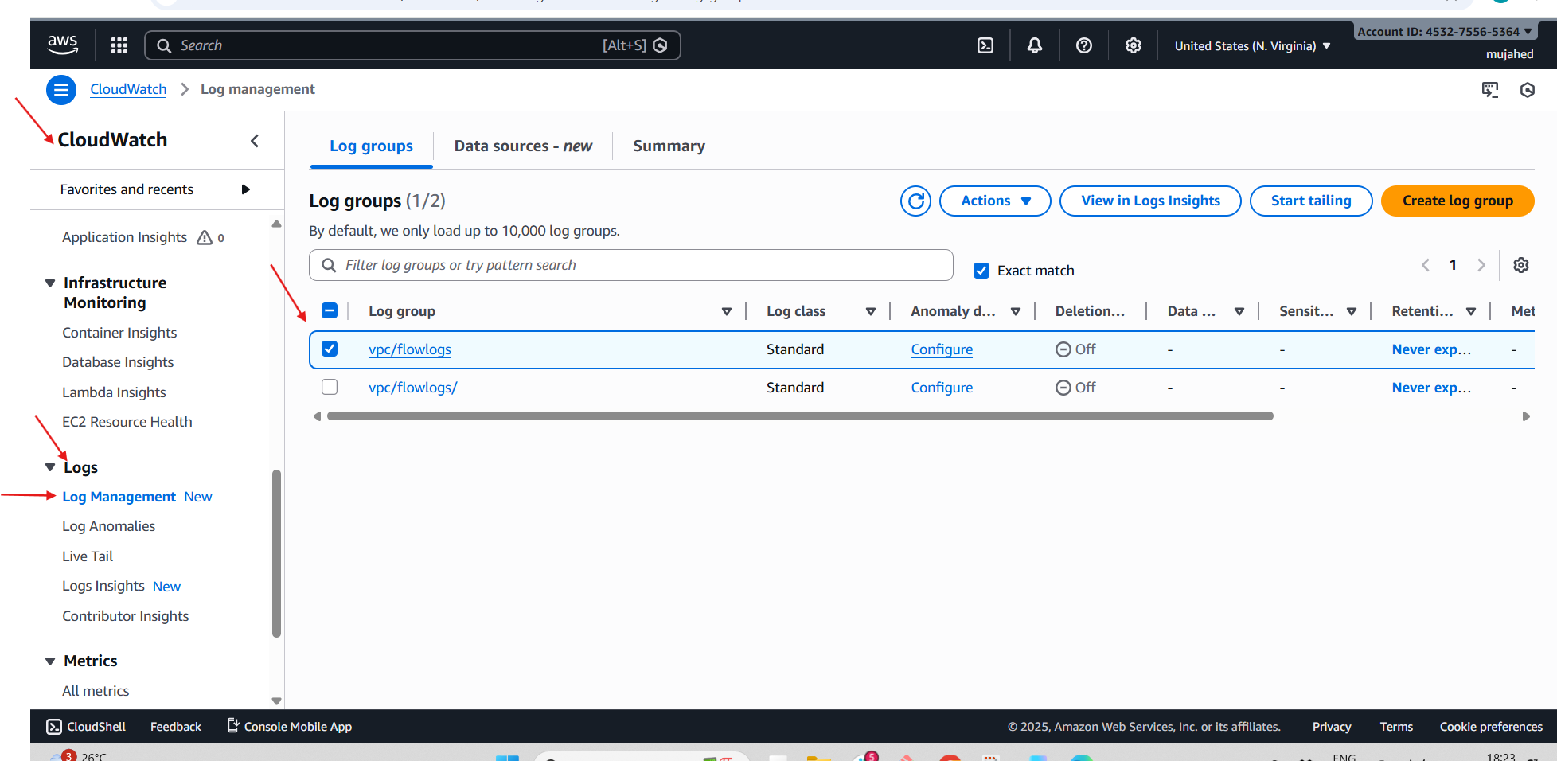

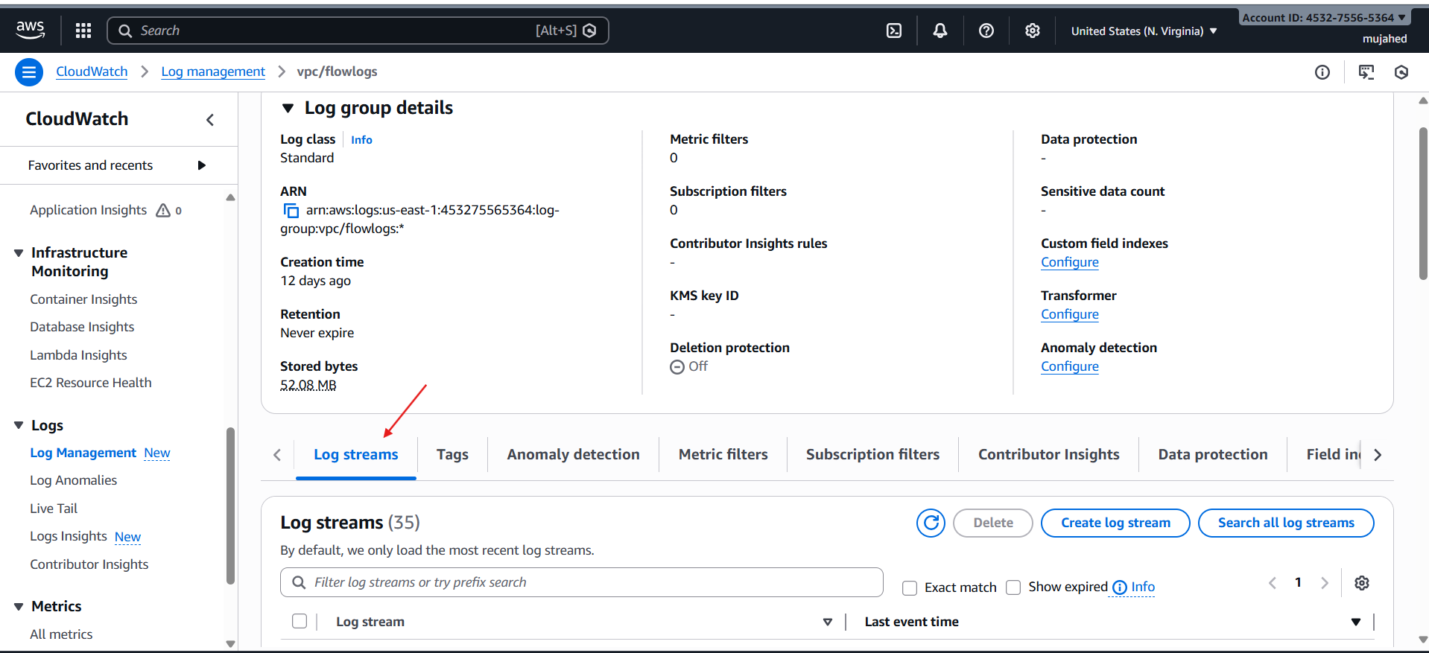

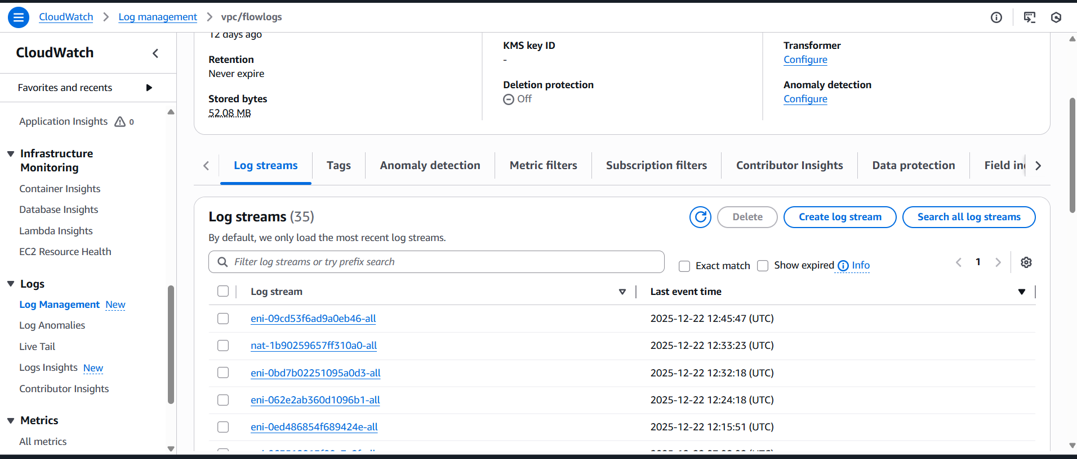

* **VPC Flow Logs are WORKING properly and being sent to CloudWatch Log Group vpc/flowlogs**

11.Create monitoring dashboards to monitor CPU utilization and to monitor the Apache service.

* **create monitoring dashboards for CPU utilization and the Apache service, you will need to utilize AWS CloudWatch to aggregate both standard and custom metrics.**

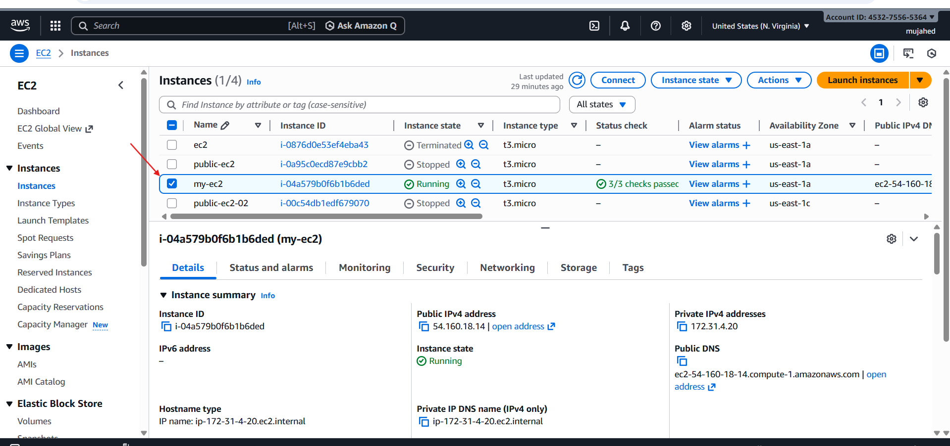

* **(CPU) and software availability (Apache) of an EC2 instance by consolidating metrics into a single, centralized CloudWatch dashboard.**
* **An active EC2 instance (e.g., my-ec2 with ID i-04a579b0f6b1b6ded) running Amazon Linux 2023.**
* **The Apache HTTP Server (httpd) installed on the instance.**
* **sudo yum install httpd.**
* **sudo systemctl enable --now httpd.**
* **Navigate to the CloudWatch Console and select Dashboards.**
* **Click Create dashboard and name it (e.g., httpd).**

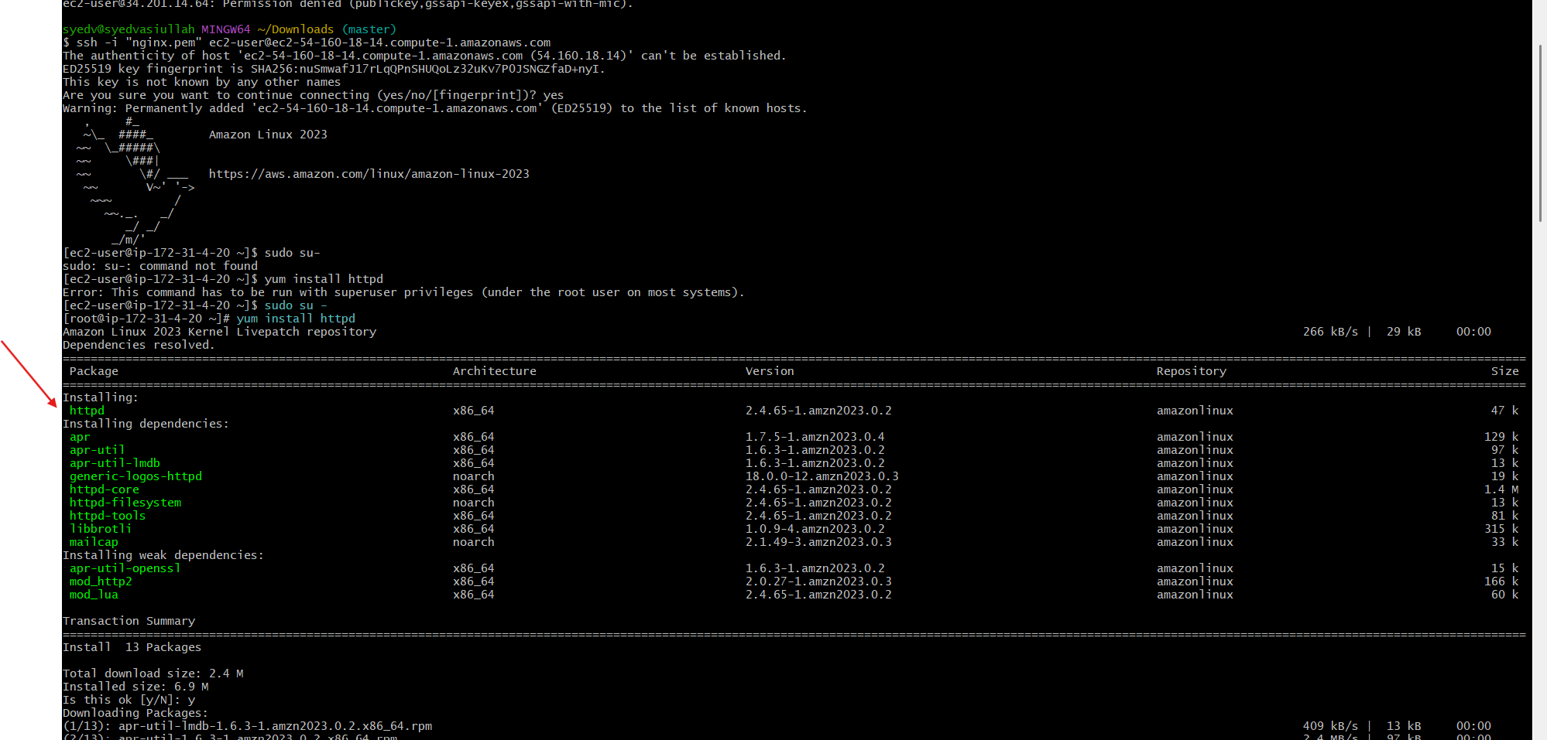

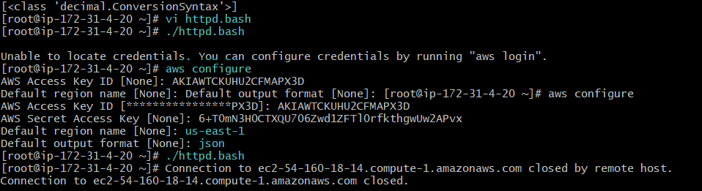

* **Choose a Line or Number widget.**
* **Select AWS/EC2 > Per-Instance Metrics and find CPUUtilization for your instance.**
* **Check Dashboard Visibility: Verify that the new dashboard httpd appears in your Custom Dashboards list.**
* **Missing Credentials: The custom script may fail with an "Unable to locate credentials" error if aws configure has not been completed.**

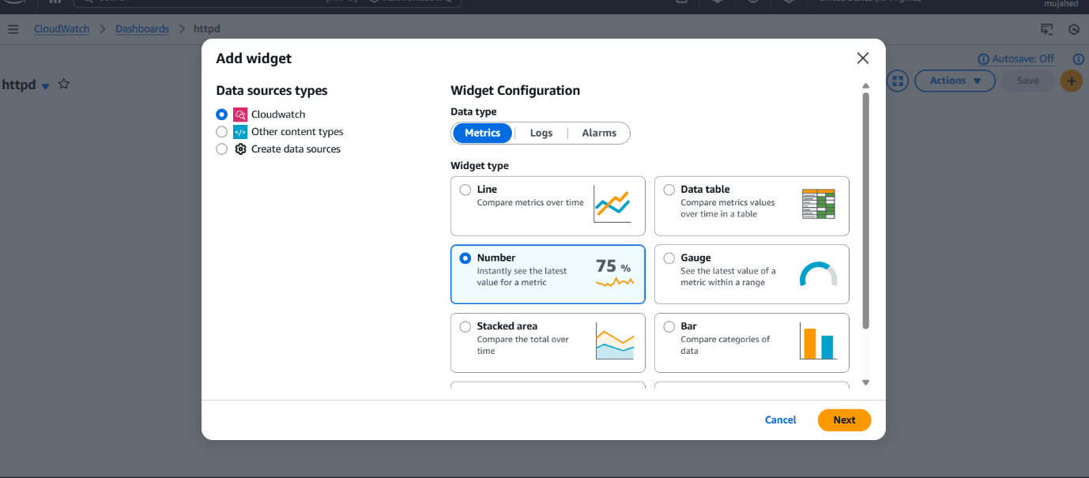

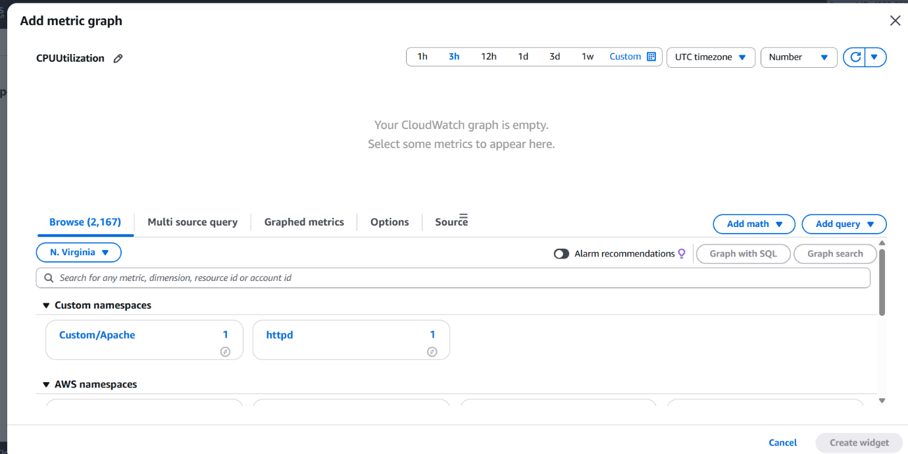

* **Empty Graphs: If the custom metric is not sent frequently enough, the CloudWatch graph may appear empty initially until several data points are collected.**

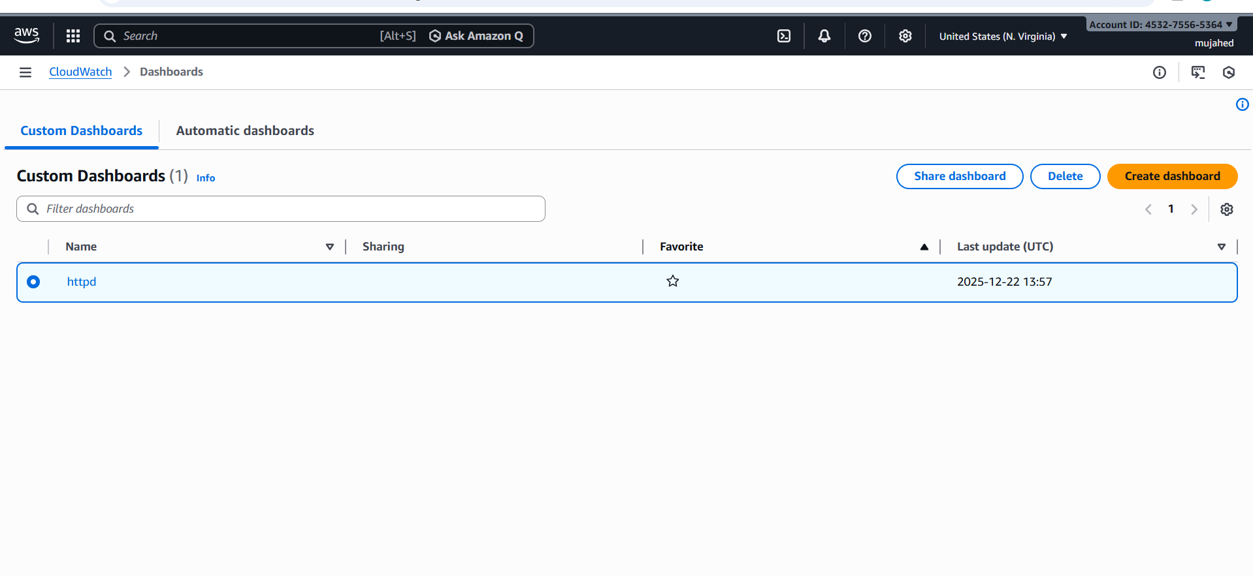

12.If CPU utilization is more than 70%, then it should trigger auto scaling and launch new instance.

* **To trigger auto scaling at 70% CPU:**

**We need 4 things:**

* **Launch Template (your EC2 configuration)**
* **Auto Scaling Group (ASG)**
* **Target Group already exists (we used it for ALB) → we will attach ASG to this**
* **Scaling Policy: CPU > 70% → Add 1 instance**
* **we have to create a launch tamplate**
* **Create Launch Template**
* **Go to:**
* **EC2 → Launch Templates → Create launch template Fill these:**

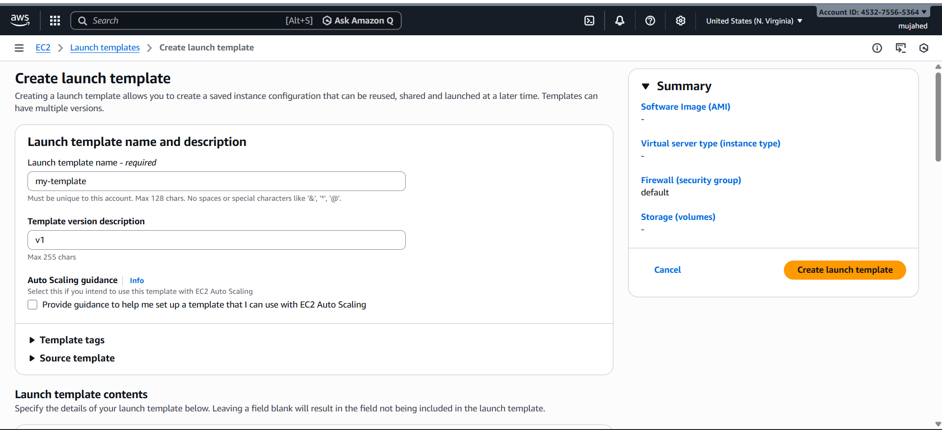

* **Template Name: my-template**
* **select the ami and key pair and SG group**
* **And create the launch templete**

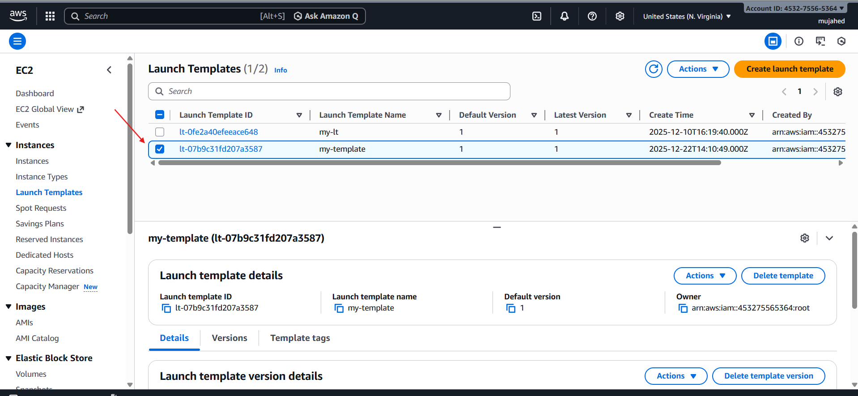

* **EC2 → Auto Scaling Groups → Create ASG**
* **In very first select the launch template which we created**
* **Next select the vpc which we created and then select the availability zones of subnets from that vpc**

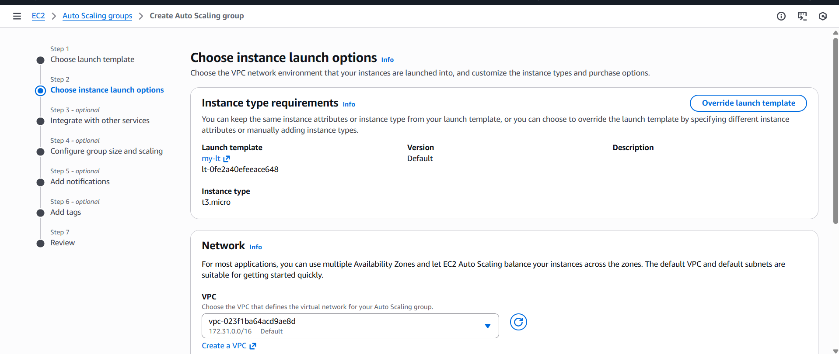

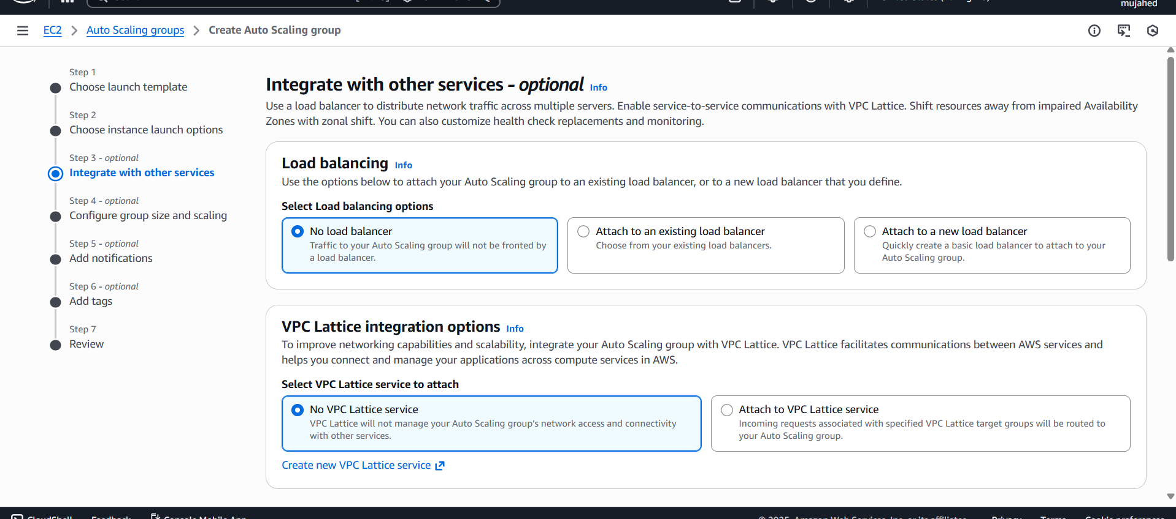

* **Set Group Size scaling**
* **Desired capacity: 2**
* **Minimum capacity: 1**
* **Maximum capacity: 2**

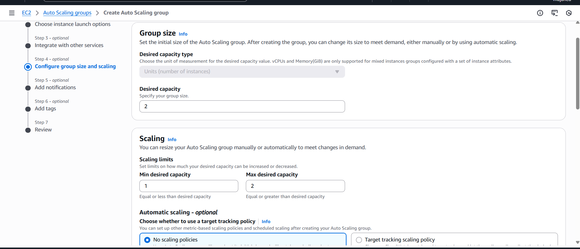

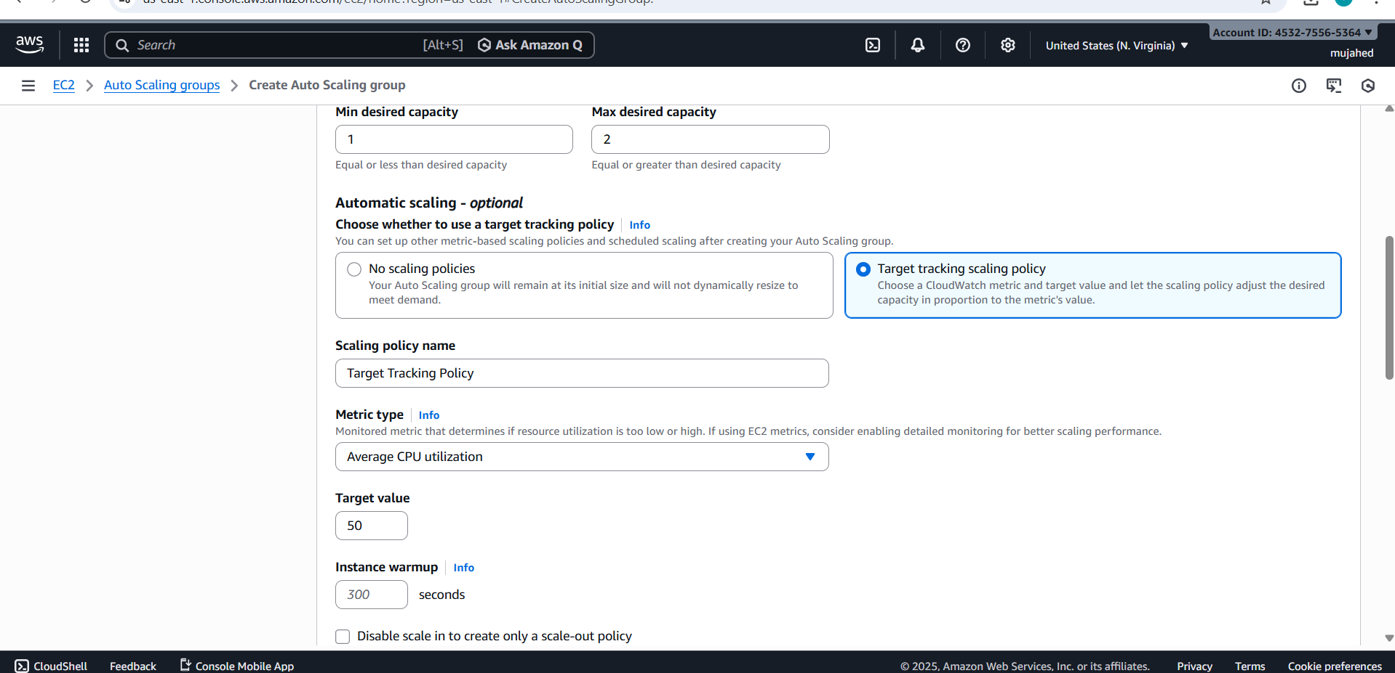

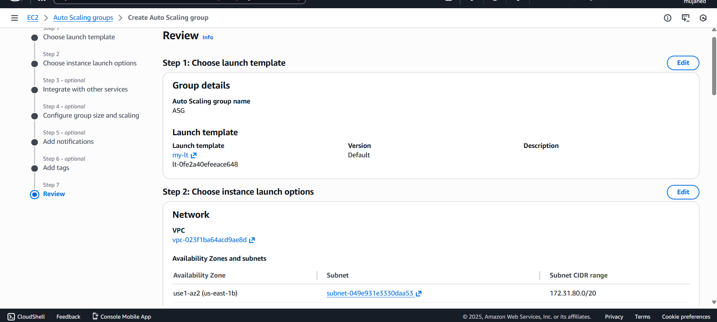

* **Watch CPU of all EC2 in the group**

**• If CPU > 70% for ~2 minutes**

**• It launches a new EC2 instance automatically**

**• The new EC2 attaches to:**

* **Target Group**
* **Load Balancer**
* **VPC**
* **Security Group**

**Everything works automatically**